Technology: Risk Assessment Title: Plastic Trimming Rotary Cutters AUGUST2016
This is a generic Risk Assessment that must be modified to suit your place of work. The Risk Assessment modifications should take into consideration the activity, age/stage/pupil ability, department/working environment and the experience of the teacher in charge. If Control Measures Required as described are implemented the risk is reduced to an acceptable level for mainstream students.
Identify the Hazards | Who is at Risk? | What is the Harm? | Activity Taking Place | Control Measures Required | Additional Information
Employees should be made aware of the following hazards.  1. Hand, Hair or  Clothing Entanglement  2. Contact From  Ejected Pieces  3. Contact From  Spinning Work Pieces  4. Electric Shock  6. Finger Trap Risk  7. Contact With Sharp Edges  8. Contact From  Inadvertent Starting  9. Operator Pushed  10. Falling On  Slippery Floor  11. Blunt Cutter  12. Contact From  Ejected Flange Cutter  13. Allen Key Removal  14. Wood Use  15. Extraction Use  16. Fire Risk  17. Hot Surface Risk  18. Tungsten Carbide  Disc Cutter  19. Heavy Machine  20. Wooden Rebate Cutting  21. Lack of Maintenance | Technology teachers, technicians and pupils  Technology teachers, technicians and pupils  Technology teachers, technicians and pupils  Technology teachers, technicians and pupils  Technology teachers, technicians and pupils  Technology teachers, technicians and pupils  Technology teachers, technicians and pupils  Technology teachers, technicians and pupils  Technology teachers, technicians and pupils  Technology teachers, technicians and pupils  Technology teachers, technicians and pupils  Technology teachers, technicians and pupils  Technology teachers, technicians and pupils  Technology teachers, technicians and pupils  Technology teachers, technicians and pupils  Technology teachers, technicians and pupils  Technology teachers, technicians and pupils  Technology teachers, technicians and pupils  Technology teachers, technicians and pupils  Technician | Long hair, loose clothing etc, can become entangled in moving parts of the machine.  Broken pieces of material can be violently ejected.  Unexpected spinning of hand held work pieces could cause injuries to hands.  Trimming machines present an electric shock hazard.  Moveable and adjustable table surface presents a finger trap risk.  The rotating sharp edge can cause cuts if fingers or hands touch it.  The machine should be switched off whenever not in use.  Lack of space around the machine can lead to the operator being pushed by passers-by.  Slippery floor surfaces or loose items around the machine can cause slips that result in contact with moving parts.  Blunt cutters can lead to excessive force being placed upon it.  Broken plastic pieces can be violently ejected.  Leaving an allen key attached risks ejecting it towards user.  The tilting table is designed for use with the drum sander only.  Use extraction whenever possible on the 2020 model.  Continuous friction contact between materials and abrasive surfaces can lead to fire risk.  After cutting the work piece can be hot.  The disc cutter is an unguarded turning cutting surface.  The machine can cause broken bones or limbs if it falls from work surface.  Cutting a rebate on wood requires a fence to guide for accurate depth.  Regular maintenance is required to keep the machine suitable for use in a school workshop. | Plastic Trimming, Drum Sander or Wooden Rebate  Plastic Trimming, Drum Sander or Wooden Rebate  Plastic Trimming, Drum Sander or Wooden Rebate  Plastic Trimming, Drum Sander or Wooden Rebate  Drum Sander  Plastic Trimming, Drum Sander or Wooden Rebate  Plastic Trimming, Drum Sander or Wooden Rebate  Plastic Trimming, Drum Sander or Wooden Rebate  Plastic Trimming, Drum Sander or Wooden Rebate  Plastic Trimming or Wooden Rebate  Plastic Trimming, Drum Sander or Wooden Rebate  Plastic Trimming, Drum Sander or Wooden Rebate  Drum Sander  Plastic Trimming, Drum Sander or Wooden Rebate  Plastic Trimming, Drum Sander or Wooden Rebate  Plastic Trimming, Drum Sander or Wooden Rebate  Plastic Trimming, Drum Sander or Wooden Rebate  Plastic Trimming, Drum Sander or Wooden Rebate  Wooden Rebate  Plastic Trimming, Drum Sander or Wooden Rebate | WARNING. Learners should only use electric rotary cutters when they have been assessed and the assessment has shown that they are competent, and they are under the direct supervision of specifically trained employees.  This machine is designed for trimming the waste material from around vacuum formings made from plastic sheet up to a maximum thickness of 3mm or cutting a rebate in wood.  Long hair and loose clothing should be secured so as to not come into contact with moving parts. Jewellery should be removed.  Gloves or bandages should not be worn whilst operating this machine.  Suitable eye protection conforming to BS EN 166:2002 1B (medium energy impact) should be used whilst operating this machine.  The plastic or wooden piece should be securely hand held and the user must be of sufficient strength to hold it.  The emergency stop button should be clearly visible to the operator.  The plastic trimming machine should be provided with a means of electrical isolation using a fused isolating switch on or adjacent to the machine, and it is controlled by a starter incorporating overload protection and no-volt release.  The machine should be included in a planned maintenance programme that should include electrical safety inspections and tests.  The flat table top must be locked in place before operating. The table tilt must only be used when using the drum sander tool on wood.  The flange tool consists of a cutter shielded by bearings above and below. The bearings serve to both hide the blade for safety and to act as a spacer controlling the width of the flange.  Then machine should not be left powered on when unsupervised.  There should be sufficient space around the machine to prevent the operator from being accidently pushed by passers-by.  The floor surface should not be slippery and should be kept free of loose items.  Blunt cutters should be removed from the machine for repair or disposal immediately.  Only supervising Technology teachers and technicians should replace the cutter. The cutter should be checked before starting the machine.  To change the tool the machine must be switched off and isolated. The allen key must be removed after use each time. The cutting tools should only be changed by Technology teacher or technicians.  The tilting table on the 2020 can tilt up to 10 degrees enabling draft angles to be produced on wooden moulds. This tilt should only be used when using the drum sander on wood.  LEV should be used wherever possible. If only small or shorts bursts of use take place, it is for the school to decide if LEV is required.  The machine is intended for use with non-ferrous materials, therefore there is no direct source of ignition.  Immediately after cutting, the edges of the plastic shapes can be hot. Contact with fingers or hands should be avoided.  The correct and safe use of the disc cutter must be demonstrated to pupils using the machine when cutting out vacuum formed shapes.  The 2010 machine weighs 19kg and the 2020 weighs 21kg. It should be used on a flat secure surface with at least 600mm x 600mm clearance.  The 2020 machine should be used to cut rebates in wood as the fence allows the cut to be controlled and accurate.  The machine should be part of a regular department maintenance schedule. | Reference BS 4163:2014  Manufacturer’s instructions and guidelines must be read through and retained before using this machine.  It is recommended that the socket be protracted by an RCD device or similar, so that in the unlikely event of a short circuit the supply would be isolated automatically.  The power cable must be kept away from the cutting tool at all times.  The tilt table should be set under supervision from the Technology teacher or technician.  SSERC recommends all machines being connected to a workshop hardwired power system.  The tilting table should be securely fixed and the abrasive tool checked to be free to rotate before powering on.  Check that the fitted tool is positioned clear on the machine table, and is secure, before any attempt is made to switch on the machine.  The base of the machine can be bolted to a work surface or securely G-clamped.

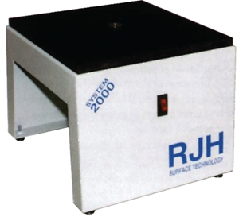
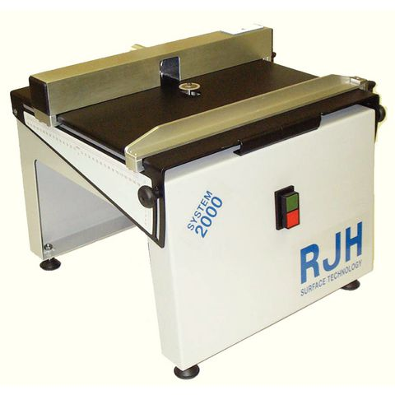
RJH Gerbil 2020 model
RJH Gerbil 2010 model

