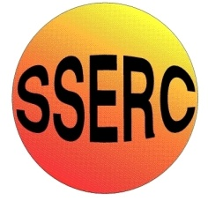Technology: Risk Assessment Title: Forge FEBRUARY2015
This is a generic Risk Assessment that must be modified to suit your place of work. The Risk Assessment modifications should take into consideration the activity, age/stage/pupil ability, department/working environment and the experience of the teacher in charge. If Control Measures Required as described are implemented the risk is reduced to an acceptable level for mainstream students.
Identify the Hazards | Who is at Risk? | What is the Harm? | Activity Taking Place | Control Measures Required | Additional Information
Employees and learners should be made aware of the following hazards.  1. Skin Burns  2. Brick Disintegration  3. Hot Ceramic Chips  4. Exploding Materials  5. Scalding Risk  6. Dangerous Gases  7. Unauthorised Use  8. Trip Hazard | Technology teachers, technicians and students  Technology teachers, technicians and students  Technology teachers, technicians and students  Technology teachers, technicians and students  Technology teachers, technicians and students  Technology teachers, technicians and students  User  Technology teachers, technicians and students | Care should be taken when carrying or moving hot metals (particularly metals at black heat that might not appear hot).  Clay and concrete bricks should not be heated as they can disintegrate violently.  Ceramic chips remain hot for a considerable time after the heat source has been removed.  Foreign materials present in a forge can cause fumes and stones to explode.  Quenching of hot metals (particularly tubular metals) can present a risk of scalding.  Fuel combustion can produce dangerous gases.  Unauthorised use.  Loose materials and objects can present a trip or slip hazard around the Forge. | Heating and shaping metals  Heating and shaping metals  Heating and shaping metals  Heating and shaping metals  Heating and shaping metals  Heating and shaping metals  Heating and shaping metals  Heating and shaping metals | Forge work should only be completed by Technology teachers and technicians who are trained and competent in the process.  Appropriate PPE should always be used. Fire resistant aprons and protective footwear should be used. A face shield conforming to BS EN 166:2002, 1 9B should be worn.  After completion, a CAUTION – HOT METAL sign should be placed near the Forge to warn people of the presence of hot temperatures.  Firebrick or other refractory materials should be used for the brazing base. Anvils should be mounted on a stable base at an appropriate height for the user. Anvils and quenching tanks should be sited as close as possible to the hearth or forge.  Tools should be appropriate and of the correct size for lifting metals out from amongst heated ceramic chips. Tools should be quenched and stored safely after use.  Foreign materials or damaged ceramic chips should be removed and replaced before initial ignition.  Hot metal should be held using appropriately shaped tongs. Quenching should be a bit-by-bit process to avoid the whole piece of hot metal being submerged in one go.  LEV should be provided to remove fumes.  All power must be shut off and interlocked when not in use or when no supervision is present.  Floors should be kept clear of any loose materials and tools. Ceramic chips that have been kicked under the Forge during work should be allowed to cool before being disposed of. | Reference BS 4163:2014  Contact SSERC for details of training and qualification.  All persons involved in forging metal should know where all isolation stop switches are located in case of a need to emergency stop.  Observers should be at least 2 metres away from the heated Forge at all times.  Anvils and their base should be checked regularly to avoid the risk of it toppling over during use.  Check manufacturer’s instructions for the recommended type of ceramic chips to be used.  Blackened and damaged ceramic chips should be removed after cooling down.  A cover can be used when the Forge is not in use to reduce dirt and dust gathering.  Never fill the water pale or container over two thirds full to avoid water spillage on the floor.  Using a metal pale instead of a plastic bucket reduces the risk of hot metal touching the bucket base and melting it whilst quenching.  Best practice is an interlocked system where the LEV automatically activates when the Forge is being used.

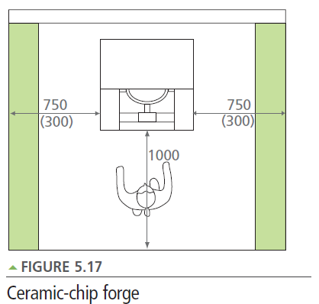

from Design and Technology Accommodation in Secondary Schools – A Design Guide (DfES 2004)
The green area is an overlap of space allocated to machines only (250mm unless otherwise stated.)

