Technology: Risk Assessment Title: Circular Saw (Student Specific Version) SEPTEMBER2015
This is a generic Risk Assessment that must be modified to suit your place of work. The Risk Assessment modifications should take into consideration the activity, age/stage/pupil ability, department/working environment and the experience of the teacher in charge. If Control Measures Required as described are implemented the risk is reduced to an acceptable level for mainstream students.
Identify the Hazards | Who is at Risk? | What is the Harm? | Activity Taking Place | Control Measures Required | Additional Information
Operators should be aware of the following hazards.  1. Contact From  Inadvertent Starting  2. Unauthorised Use | Students  Unauthorised user | Inadvertent starting of the machine, which can present a hazard.  Unauthorised use means that proper training, safe use and proper supervision are not present. | Cutting material on the circular saw  Cutting material on the circular saw | Learners in schools should not use Circular Saw machines. Learner use is restricted to those in further education who are following a recognized training course in wood machining, and learners in teacher training establishments who are being trained in the safe use of workshop machines.  The circular saw should be interlocked with only competent and trained Technology teachers and technicians as key holders.  The circular saw should not be left activated when not being used. Circular saws are typically located in the technician cutting room and students should be prohibited from entering this area unsupervised. | Circular sawing machines are High-Risk Woodworking Machinery.  Reference BS4163:2014  The Circular Saw machine is typically located in the Technology cutting room. This room should have restricted access to reduce the risk of any unauthorised use.  Clear restricted access signage should be present on all entry doors to Technology cutting room.

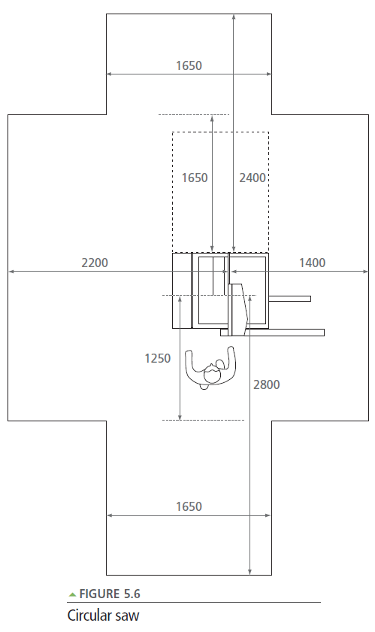

from Design and Technology Accommodation in Secondary Schools – A Design Guide (DfES 2004)

