Technology: Risk Assessment Title: Centre Lathe AUGUST2016
This is a generic Risk Assessment that must be modified to suit your place of work. The Risk Assessment modifications should take into consideration the activity, age/stage/pupil ability, department/working environment and the experience of the teacher in charge. If Control Measures Required as described are implemented the risk is reduced to an acceptable level for mainstream students.
Identify the Hazards | Who is at Risk? | What is the Harm? | Activity Taking Place | Control Measures Required | Additional Information
Employees and learners should be made aware of the following hazards.  1. Hand, Hair or Clothing Entanglement  2. Impact From  Ejected Pieces  3. Electrical Shock  4. Closing Movements  Trapping Fingers  5. Contact With  Sharp Edges  6. Skin Irritation  From Fluids  7. Impact From  Ejected Swarf  8. Contact From  Inadvertent Starting  9. Operator Pushed  Whilst Working  10. Falling On  Slippery Floor  11. Heavy Lifting  12. Unauthorised Use  13. Poor Lighting  14. Cold Temperature  15. Snagging or Caught Fingers During Emery  Cloth Finishing | Technology teachers, technicians and students  Technology teachers, technicians and students  Technology teachers, technicians and students  Technology teachers, technicians and students  Technology teachers, technicians and students  Technology teachers, technicians and students  Technology teachers, technicians and students  Technology teachers, technicians and students  Technology teachers, technicians and students  Technology teachers, technicians and students  Technology teachers, technicians and students  User  Technology teachers, technicians and students  Technology teachers, technicians and students  Technology teachers, technicians and students | Long hair, loose clothing, etc, can become entangled in moving parts of the lathe.  Work pieces, chuck keys, broken cutting tools, swarf, etc., can be violently ejected from the lathe.  Centre Lathes can present a hazard of electric shock.  Closing movements between parts under power feed can be a trapping hazard.  Sharp edges on tools, work pieces and swarf can cause cuts.  Contact with cutting fluids, oil and grease can irritate the skin.  Swarf can jam or be ejected if allowed to build up.  Inadvertent starting of the machine can present a hazard.  Lack of space around the machine can lead to the operator being pushed by passers-by.  Slippery floor surfaces or loose items around the machine can cause slips that result in contact with moving parts.  Manual handling (lifting) of heavy equipment (e.g. chucks, faceplates) can present a hazard.  Unauthorised use.  Injury is possible due to poor lighting and an inability to see the workpiece or cutting tool clearly.  Cold temperature can affect coordination and hand control when using Centre Lathe controls.  Emery cloth held against the rotating components can snag and result in broken fingers or amputation. | Metal turning and operations  Metal turning and operations  Metal turning and operations  Metal turning and operations  Metal turning and operations  Metal turning and operations  Metal turning and operations  Metal turning and operations  Metal turning and operations  Metal turning and operations  Metal turning and operations  Metal turning and operations  Metal turning and operations  Metal turning and operations  Deburr or polish of metal components | The school or similar establishment should decide which machinery is suitable for use by each group of learners. The decision should be based on student maturity and competence, the level of supervision, and local authority/employer and national guidelines. In general the following recommendations should apply. Learners should be trained and instructed in safe operating methods by a competent employee (Technology teacher or technician), who has attended a recognised training course. A record of their training should be kept. Learners should be assessed as mature and competent before operating the machinery, and should be continually supervised.  Long hair and loose clothing should be secured so as to not come into contact with any moving parts. Jewellery should be removed. No scarves should be worn. Cloth gloves should not be worn. Hands or fingers with bandages must not be allowed to use the Centre Lathe.  Stock bar should not project beyond the headstock. If this is unavoidable, the portion of stock bar projecting beyond the headstock should be guarded to prevent entanglement. The hole that allows a long stock bar to project should be covered by a metal plate secured with suitable screws or bolts when not in use.  The machine should be provided with fixed guards (removable only with the use of a tool), or alternatively interlocked guards that enclose the drive mechanisms including the headstock spindle end.  SSERC recommends wearing eye protection PPE conforming to BS EN 166:2002 1B is used while operating the machine.  Work mounted to a faceplate, a chuck or between centres should be properly secured and balanced to prevent excessive vibration. The rotational clearance should also be checked by hand before starting the machine. The cutting tool should also be carefully checked for security before starting the machine.  The machine should be provided with a means of electrical isolation using a fused isolating switch on or adjacent to the machine, and that it is controlled by a starter incorporating overload protection and no-volt release. The machine should also be provided with a conveniently positioned and accessible, emergency stop switch (which could be the normal “off” switch) or other suitable control device that can quickly stop the machine in an emergency.  The machine should be included in a planned maintenance programme that should include electrical safety inspections and tests.  The machine should be electrically isolated before any internal mechanisms are adjusted. The drive to feed shafts and lead screws should be disconnected until required. The chuck key, preferably spring-loaded, should be removed immediately after use and before starting the machine.  The machine should be fitted with a suitable chuck guard. The spindle mandrel should be guarded. If feed shafts and lead screws are not sufficiently protected by the overhung of the bedways and/or saddle and swarf trays, an appropriate guard should be provided.  Files and abrasive tape should not be used on centre lathes if possible.  Coolant nozzles should not be adjusted while the machine is in operation.  The machine should be stopped before measuring or gauging and the cutting tool positioned to minimise possible contact.  Tool-post grinding machines should only be used on lathes for which they have been specifically designed.  Control of Substances Hazardous to Health Regulations (COSHH) requires exposure to metalworking fluids to be prevented where reasonably practical and adequately controlled.  Contact with skin should be kept to a minimum. Hands should be washed thoroughly after using the Centre Lathe.  Metalworking fluids, if used, should be mixed and changed in accordance with the manufacturer’s instructions. Where a coolant a tank and pump is fitted the tank and system should be drained every 12 months, the system flushed through with clean water and the tank refilled with fresh coolant.  Swarf should not be allowed to accumulate as it can become entangled or ejected by the chuck or work piece. Swarf should not be removed while the machine is operating. A suitable implement should be used to avoid hand contact with swarf.  The Centre Lathe should be interlocked and always locked off when not in use.  There should be sufficient space around the lathe as shown below to prevent the operator from being accidentally pushed by passers-by. The machine should be fitted with a suitable chuck guard. Only one person at a time should operate the machine.  The floor surface should not be slippery and should be kept free of loose items and swarf.  Any spillage of fluids must be safely removed before work on the Centre Lathe is undertaken.  An assessment should be carried out and measures implemented to minimise risks associated with lifting heavy items (e.g. use of lifting aids, team lifts, correct lifting techniques).  Substantial footwear should be worn to protect feet.  Only a competent trained person should supervise the use of centre lathes. The trained person should be trained with recognised qualifications to industry standards.  Supplementary lighting should be provided for the Centre Lathe if the main room lighting is not sufficient. Supplementary lighting should conform to BS EN 60204-1. Lamps should not operate at more than 50 V a.c. If the switch for the supplementary light is not easily accessible to the machine tool operator, another switch should be provided adjacent to the light source. Lighting should be provided with a deep shade to prevent glare from polished surfaces.  Work areas should be maintained at a temperature comfortable to work in when appropriate protective clothing is worn. Heating should be available in rooms used for the preparation of materials as well as teaching areas.  Emery cloth should never be used in an operational Centre Lathe. For a cosmetic finish the component must be removed from the Centre Lathe, held in one hand and polished by emery cloth held in the other hand. | Reference BS 4163:2014  Manufacturer’s instructions and guidelines must be read through and retained before using this machine.  Safety and PPE signage should be clearly displayed on or near the Centre Lathe.  A face shield conforming to BS EN 166:2002 1 9B can also be worn whilst operating the centre lathe, as it offers full face protection.  The risk of electric shock is reduced by good maintenance and the use of double insulated machines.  As an alternative to guarding of the lead screw and feed shaft, the drive to these items can be disconnected by removal of a gear from the change wheel drive. If the drive shaft or lead screw is required, a special risk assessment showing how the additional hazard presented by the unguarded shaft will be removed or reduced might be appropriate.  Micrometers or callipers must be safely removed from the lathe before operation.  For more information see COSHH Essentials for Machining with Metalworking Fluids http://www.hse.gov.uk/metalworking/ecoshh.htm and HSE Working Safely with Metalworking Fluids 08/11 http://www.hse.gov.uk/pubns/indg365.pdf  Barrier creams or appropriate disposable protective close fitting latex gloves may be used if necessary.  Swarf should be regularly removed and not allowed to gather in the bed.  Only competent Technology teachers and technicians who have received Centre Lathe training should be key holders.  Manual handling tasks associated with changing heavy chucks and faceplates, etc., can be beyond the physical ability of some persons.  Only competent and trained Technology teachers and technicians should possess the power key to operate the Centre Lathe.  For more information see HSE Engineering Information Sheet No.2 – Accidents at Metalworking Lathes Using Emery Cloth 11/04 http://www.hse.gov.uk/pubns/eis2.pdf
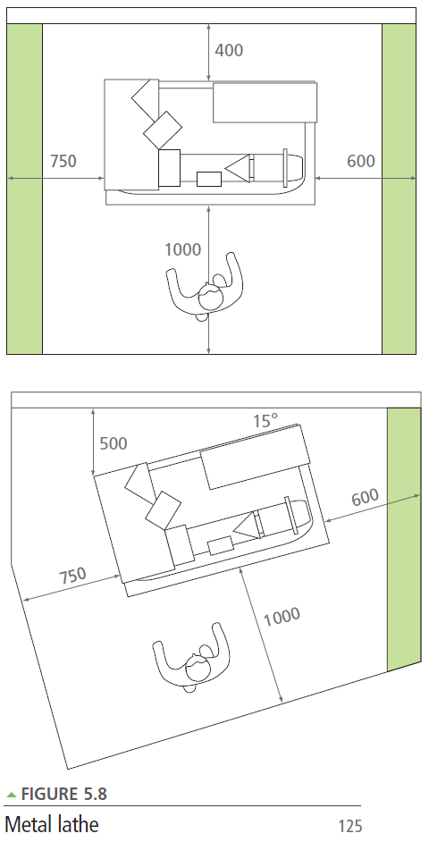

The green area is an overlap of space allocated to machines only (250mm unless otherwise stated.)
from Design and Technology Accommodation in Secondary Schools – A Design Guide (DfES 2004)

