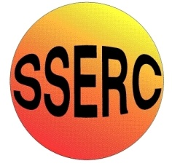Technology: Risk Assessment Title: Casting JANUARY2016
This is a generic Risk Assessment that must be modified to suit your place of work. The Risk Assessment modifications should take into consideration the activity, age/stage/pupil ability, department/working environment and the experience of the teacher in charge. If Control Measures Required as described are implemented the risk is reduced to an acceptable level for mainstream students.
Identify the Hazards | Who is at Risk? | What is the Harm? | Activity Taking Place | Control Measures Required | Additional Information
Employees and learners should be made aware of the following hazards.  1. Skin Burns  2. Explosion Risk  3. Violent Reactions  4. Fumes Hazard 1  Fumes Hazard 2  Fumes Hazard 3  5. Heavy Lifting  6. Damaged Crucible  7. Hot Temperature  8. Unauthorised Use  9. Unknown Materials | Technology teachers, technicians and pupils  Technology teachers, technicians and pupils  Technology teachers, technicians and pupils  Technology teachers, technicians and pupils  Technology teachers, technicians and pupils  Technology teachers, technicians and pupils  Technology teachers, technicians and pupils  Technology teachers, technicians and pupils  Technology teachers, technicians and pupils  User  Technology teachers, technicians and pupils | Hot molten metal can present a hazard.  Molten metal in contact with moisture on moulds and equipment can cause an explosion.  A violent reaction can occur between molten aluminium and various metallic oxides [e.g. iron oxide (rust)].  Degassing tablets cause fumes that can be harmful if inhaled.  Some molten metals can give off harmful fumes.  Expanded polystyrene patterns can produce large quantities of harmful fumes when in contact with molten metal.  Manual handling of heavy, hot crucibles and mould boxes can present a hazard.  Damaged crucibles can result in spillage of molten metals and the unit coming apart whilst being lifted.  The hot temperatures required and the necessity for PPE clothing can make the user hot and uncomfortable.  Unauthorised use.  Placing unknown materials into the casting pot increases the risk of explosion or hazardous fumes | Aluminium Ingot Casting  Aluminium Ingot Casting  Aluminium Ingot Casting  Aluminium Ingot Casting  Aluminium Ingot Casting  Aluminium Ingot Casting  Aluminium Ingot Casting  Aluminium Ingot Casting  Aluminium Ingot Casting  Aluminium Ingot Casting  Aluminium Ingot Casting | Casting should only be completed by experienced Technology teachers and technicians who are competent and trained in the process. A second supervising member of staff is recommended to assist during the process.  All persons involved in preparing and pouring molten metal should wear appropriate PPE (substantial footwear, suitable face protection, heat resistant gloves, spats and gaiters, leather apron).  Any persons not directly taking part in pouring hot metal should be kept at a safe distance (minimum of 2 metres.)  Oil-bonded sand should be used if possible. If green sand is used, the moisture content should be kept to the minimum required to bond the sand.  Only equipment specifically intended for metal casting should be used. Safety tilt crucible furnaces should be used. Casting should only be carried out in a designated dry teaching/demonstration area.  Aluminium alloys should not be melted in a plain iron pot.  LEV should be used at all times during casting to remove harmful fumes.  A quarter or half of a degassing tablet is suitable for use in a Flamefast school crucible pot per fill.  LEV should be used at all times during casting to remove harmful fumes.  Larger scale casting work should only be carried out using aluminium or zinc based alloys.  LEV should be used at all times during casting to remove any harmful fumes.  Measures should be implemented to minimise risks associated with lifting heavy hot crucibles (e.g. use of lifting aids, team lifts, and correct lifting techniques).  Only Technology teachers or technicians should carry out the pouring process in a continuous smooth and steady stream. Pupils should not be used to pour the molten metal.  Crucibles should be inspected prior to being preheated to avoid cracking and to remove moisture. Equipment to be brought into contact with metal should be wire brushed, and preferably coated in limestone refractory wash and thoroughly dried.  Moulding boxes used for casting should be made of steel.  Casting equipment should be included in a planned annual maintenance programme that should include any appropriate electrical and gas safety tests.  All persons involved in pouring molten metal should wear their appropriate PPE (substantial footwear, suitable face protection, heat resistant gloves, spats and gaiters, leather apron) when near, checking or pouring molten metal.  After pouring, a CAUTION – HOT MOLTEN METAL sign should be placed on the casting pit to warn others of the presence of hot temperatures (even when cooling).  Casting equipment should only be used under the supervision of a competent Technology teacher or technician with training at least to the standard specified in the Health and Safety Training Standards in Design Technology [N1], or who has equivalent recognised qualifications to industry standards.  All power must be shut off and interlocked when not in use or when no supervision is present.  Unknown materials, scrap aluminium, fizzy drinks cans or alloy wheel parts should not be used for casting. This is due to the unknown additions to the materials and increased risk of dirt or moisture being included. Only off-cuts, unwanted or imperfect aluminium ingot models should be used again after being cleared of sand and moisture. | Reference BS 4163:2014  For more information about Casting qualifications and training contact SSERC.  A face shield conforming to BS EN 166:2002, 1 9B should be worn.  All persons involved in pouring molten metal should know where all isolation stop switches are located in case of a need to emergency stop.  Observers should be at least 2 metres away from the crucible pot at all times.  Using oil bonded sand is best practice as it reduces the explosion risk.  All tools used in the process should be wire brushed and checked for any damage and rust prior to use.  Best practice is an interlocked system where the LEV automatically activates when the crucible furnace is being used.  Any crucible pot found unclean or cracked should be reported for repair immediately and removed from use.  All tools used in the process should also be wire brushed prior to use and checked for damage.  Best practice is the use of a pyrometer to check the temperature of the crucible pot from a safe distance.  It is best practice and professional courtesy to notify any janitor, cleaning or support staff that may be in the room at any point after the casting process, of the presence of cooling molten metal and casting equipment.  For more information about Casting qualifications and training contact SSERC.  Only use aluminium ingots that can be traced back to purchase.

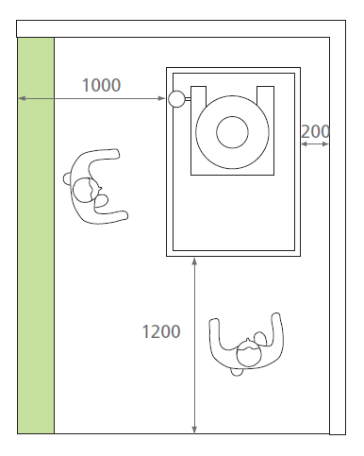
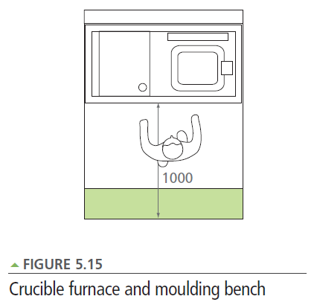
from Design and Technology Accommodation in Secondary Schools – A Design Guide (DfES 2004)

The green area is an overlap of space allocated to machines only (250mm unless otherwise stated.)

