Technology: Risk Assessment Title: Belt Sander/Band Facer SEPTEMBER2015
This is a generic Risk Assessment that must be modified to suit your place of work. The Risk Assessment modifications should take into consideration the activity, age/stage/pupil ability, department/working environment and the experience of the teacher in charge. If Control Measures Required as described are implemented the risk is reduced to an acceptable level for mainstream students.
Identify the Hazards | Who is at Risk? | What is the Harm? | Activity Taking Place | Control Measures Required | Additional Information
Employees and learners should be made aware of the following hazards.  1. Jammed Work Piece  2. Hand, Hair or Clothing Entanglement  3. Inhalation of Dust  4. Contact From  Inadvertent Starting  5. Contact From  Breaking Belt  6. Burns From  Hands and Finger Contact  7. Unauthorised Use  8. Lack of Maintenance | Technology teachers, technicians and assessed students  Technology teachers, technicians and assessed students  Technology teachers, technicians and assessed students  Technology teachers, technicians and assessed students  Technology teachers, technicians and assessed students  Technology teachers, technicians and assessed students  User  Technician | The work piece can become jammed in the sanding machine.  Hand or clothing, which can become entangled with moving parts.  Wood dust, which can be inhaled, affects the respiratory system.  Inadvertent starting of the machine can lead to accidental contact  The abrasive belt can break up and lash out.  Hands and fingers can come into contact with the abrasive surface causing cuts and serious friction burns.  Unauthorised use.  Regular maintenance will keep the machine safe for use. | Belt sanding materials  Belt sanding materials  Belt sanding materials  Belt sanding materials  Belt sanding materials  Belt sanding materials  Belt sanding materials | The school or similar establishment should decide which machinery is suitable for use by each group of learners. The decision should be based on student maturity and competence, the level of supervision, and local authority/employer and national guidelines. Learners should be trained and instructed in safe operating methods by a competent person (Technology teacher or technician), who has attended a recognised training course. Learners should be assessed as mature and competent before operating the machinery, and should be continuously supervised. BS 4163:2014  The sanding table should be of rigid construction. The gap between the table and the belt should be as small as practicable but sufficient to clear the debris. For angled sanding, it should only be possible to tilt the table downwards away from the belt, to avoid jamming timber between the table and belt.  Suitable eye protection PPE should be worn when using this machine. Long hair and loose clothing should be secured so as not to come into contact with moving parts. Jewellery should be removed. Gloves should not be worn.  The LEV system should be activated when the belt sander is used. Where an effective LEV system is not in place, a dust mask conforming to BS EN 149:2001 + A1:2009 class FFP3 should be used.  The machine should be provided with a means of electrical isolation using a fused isolating switch on or adjacent to the machine, and that it is controlled by a starter incorporating overload protection and no-volt release. A conveniently positioned and accessible, emergency stop switch (which could be the normal “off” switch) or other suitable control device that can quickly stop the machine in an emergency. Fixed guards (removable only with the use of a tool) or, alternatively, interlocked guards that enclose the drive mechanisms.  Abrasive belts should be examined before use. Torn belts should be discarded. The belts should be narrower than the belt support plate and pulleys, to protect the user from the belt edges. Belts should be set in the correct direction of rotation.  Consideration should be given to marking a “no finger zone” on the table of the machine. Adjustable guarding should be provided for the abrasive belt so that only the minimum required for the sanding operation is exposed.  The belt sander should be isolated and padlocked whenever not in use.  The machine should be included in a planned maintenance programme that should include electrical safety tests. | Reference BS 4163:2014  Belt Sander machines are high-risk woodworking machinery.  WARNING: Learners should only use belt sanders when they have been assessed and the assessment has shown that they are competent, and they are under the direct supervision of specifically trained employees (Technology teachers or technicians.)  All assessments demonstrating competence of students must be retained in the department.  Manufacturer’s instruction guide should be followed and kept within the department for future reference.  After angled sanding the table should be returned to flat position for the next user.  Suitable eye protection conforming to BS EN 166:2002 1B should be used.  LEV system must be included in a planned maintenance programme that should include electrical safety inspections and tests.  The belt when correctly ‘tracked’ should have a lock nut which fixes this adjustment. Pupils should not make any adjustments to belt tracking.  The guard lowered to ensure the area of the belt exposed is limited increases the likelihood of the belt being contained inside the machine should a breaking belt occur.  The guard should be reset before each use to limit the area of belt that is exposed between the top of the model and guard.  The risk of electric shock is reduced by good maintenance and the use of double insulated machines.

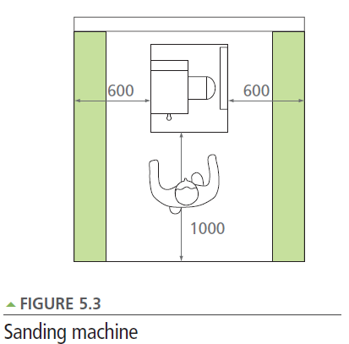
from Design and Technology Accommodation in Secondary Schools – A Design Guide (DfES 2004)
The green area is an overlap of space allocated to machines only (250mm unless otherwise stated.)

