

Chemistry Skills
Determining the melting point of Benzoic Acid
Learner Guide

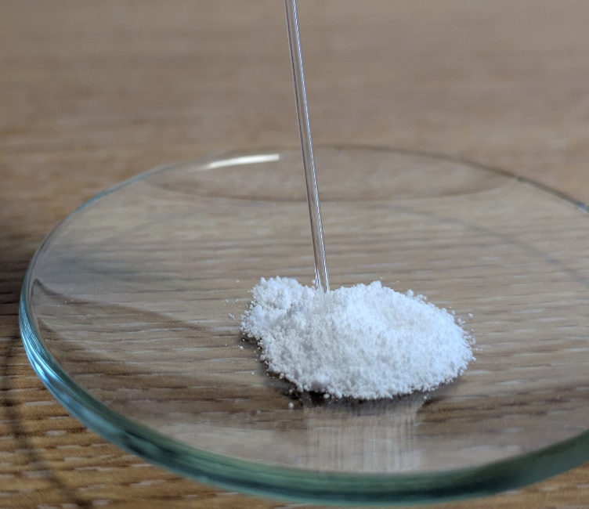

Introduction
Determining the melting point of a compound is one way to test if the substance is pure and is often used to test samples made from organic synthesis (eg of aspirin or paracetomol) as often have low melting points (below 300°C) which can be conveniently measured.
Pure samples usually have sharp melting points, for example 149.5-150°C or 189-190°C; impure samples of the same compounds melt at lower temperatures and over a wider range, for example 145-148°C or 186-189°C.
So if your sample has a melting point at the temperature you expect, it is probably what you think it is. Though be warned, there are some substances that have the same melting point. If the melting point is quite sharp, then it is likely to be pure. If a pure sample of a compound melts at 110 to 111°C, adding substantial amounts of another compound might result in a new melting point range from, say 88 to 100°C. Not just different but a wide range.
A sharp melting point at another temperature that then one you want probably means you have a fairly pure sample of something else.
The general method is to heat a sample indirectly by placing the prepared sample (usually packed in a glass capillary tube) in or on a heated medium and observing it, and the temperature, closely until melting is complete.

Melting point of benzoic acid

Preparation
- For both versions given here, you need to prepare the sample in the same way.
- Pour a small amount of your solid (benzoic acid in this case) onto a watch glass.
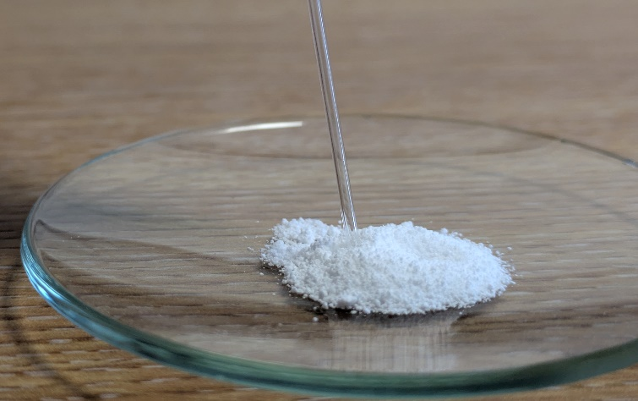
- Take a glass capillary melting point tube, which has one end sealed and the other end open.
- Jab the open end of the tube into a pile of the solid.
(If the solid is granular, grind it a little before trying to get it into the melting point tube – or it won’t fit).
- Turn the capillary tube the right way up and gently tap it on the benchtop to cause the solid to fall down to to the closed end
- Then, drop the capillary tube closed side down several times through a long narrow tube (glass tube or cut PVC pipe,).
The capillary tube will bounce as it hits the benchtop, (the glass/PVC tube is to stop it falling off the bench). The impact should pack the solid into the bottom of the tube. Failure to pack the solid well may cause it to shrink when heating, which can cause confusion as to the correct melting temperature.

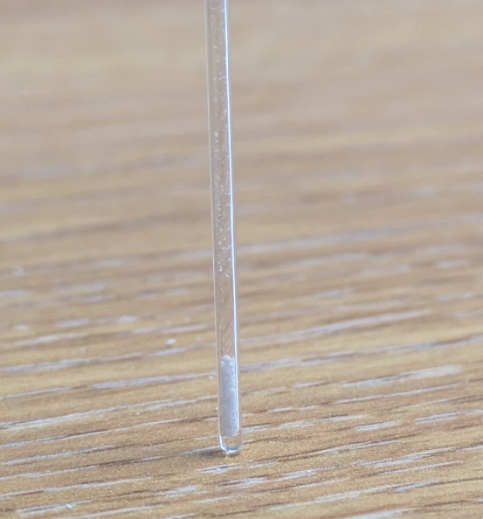
- If needed, repeat the previous steps to load sample until it is a height of 2-3mm in the tube.
It is important that the sample be no higher than ~3mm or the melting range will be too broad.

Method 1 – melting point apparatus.
There is a wide range of different melting point apparatus out there. They all work in fundamentally the same way.
- You put your prepared sample tube into a hole in an aluminium block
Depending on the age of the machine, you may need to insert a thermometer into another hole in the block
- You turn the heat on high at first
Different machines have different methods. Some simply have a manual control and you will need to watch the temperature and slow down as you get close, others allow you to set a target temperature that it will hurry up to and slowly increase from there.
The melting point of benzoic acid is 122.3°C
- When you are close, slow down the heating rate.
If this has not been done automatically. In this case, close probably means around 110 – 115°C but if your apparatus is responsive you can get closer before slowing down.
The heating rate should be slow, usually around 1–2°C per minute.
- Watch the sample carefully.
Most machines have a magnifying device and a light but you may find it easier to use a brighter light and/or a separate viewing device.
- When you see the first sign of melting, record the temperature.
- Keep heating very slowly. Once all of your sample has been melted, record the second temperature.
- These two temperatures are your melting point range.
- Repeat to make sure you get similar results.
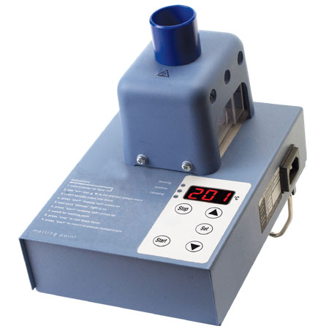
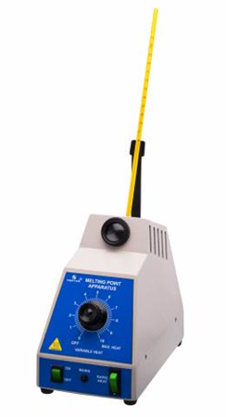

Method 2 - Thiele tube
You will need
Thiele tube | Oil*
Melting point tube(s) | Benzoic acid
Thermometer and bung | Spirit burner*
‘fixing loop”
Method
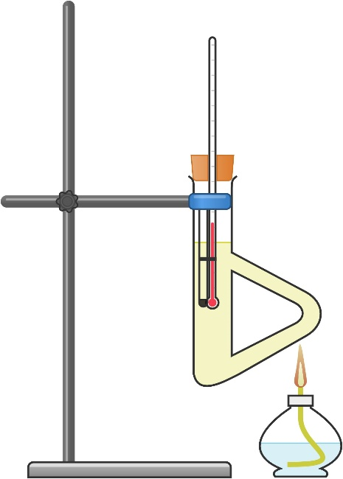
- Fill the Thiele tube with oil** – to just above the loop and hold it in a clamp.
- Take your melting point tube containing benzoic acid and fix it to a thermometer, such that the sample is adjacent to the bulb of the thermometer
- Light your spirit burner and start heating the side arm of the Thiele tube.
The melting point of benzoic acid is 122.3°C
- Once you get up to 100°C, take the burner away and then proceed slowly.
The temperature on the thermometer will continue to rise for 2-3 minutes after you stop heating so be careful.
- When you are close to the target temperature, watch the sample very closely – using a magnifying glass (or your phone camera) can help. When you see it beginning to melt, record the temperature.
- Keep heating very gently until it is all molten – record this temperature too.
- Then carry out at least two further careful determinations (by heating more gently, i.e. temperature changing only about 2 °C/min) until you obtain two consistent values.
Note that unlike boiling point, the melting point is relatively insensitive to pressure and no pressure correction needs to be made.

* We have found that using a Bunsen burner means that the temperature rises too fast and it is much harder to get accurate results.
** ethan1,2-diol can be used for temperatures up to about 140 °C. This has the advantage of being water soluble so cleaning is easier. Alternatively liquid paraffin can be used up to around 220 °C. Though a cheaper option (which we are using here, is just to use cooking oil.

