

Chemical Demonstrations
Burning Phosphorus in air
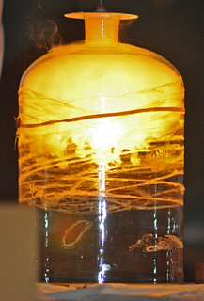
This reaction can be applied to curriculum for excellence.
CfE Higher Chemistry
I have developed my knowledge of the Periodic Table by considering the properties and uses of a variety of elements relative to their positions.
SCN 4-15a

Photo by Silyld on Flickr under a Creative Commons license

Introduction
For many years the ‘burning of phosphorus in a bell jar’ experiment was a staple demonstration to show the proportion of oxygen in air.
A piece of white phosphorus is ignited in a bell jar that sits in water simply by touching it with a hot glass rod. The fumes produced dissolve in the water, so the oxygen is removed and atmospheric pressure causes the level of water to rise.
However, many schools no longer have access to white phosphorus and it is impossible to get hold of in anything other than industrial quantities.
Helpfully, CLEAPSS devised a method by which a similar reaction can be carried out with the safer red phosphorus, which is still possible to purchase.

You will need
Glass trough | A 2l fizzy drink bottle with the base cut off.
A crown cork with the plastic lining burned off. | A kitchen blowtorch (or a mini Bunsen burner)
Red phosphorus | Clapm and stand.
Marker pen | Aluminium block (or similar)*
Rubber bung (or the bottle top) | Access to a balance
* This needs to be heat resistant as the bottle top with the burning phosphorus will sit on it. It also must be small enough to be able to sit inside the plastic bottle. Other than those specifications, it can be made of whatever you wish.

Preparation
- Scrape out the lining of a crown cork (beer bottle top) and burn off any remaining plastic in a fume cupboard.
- Using a sharp knife or a pair of scissors, cut the base off a 2 litre fizzy drinks bottle.
- Place the aluminium block in the trough and add water until the level is near the top of the block.
- Hold the neck of the bottle in a clamp and place it so that it is in the water, touching the base of the trough (or at least close to it) over the aluminium block – this will involve some fiddling about with the clamp and stand until it is in the right position.
- Use a (waterproof) marker to mark the level of the water on the outside of the bottle.
- Lift the clamp with the bottle attached free of the water.

The demonstration
Carry this part out in a fume cupboard
- Weigh out about 0.5g of red phosphorus in the bottle top.
- Place the bottle top containing the phosphorus on top of the aluminium block.
The apparatus should be set up as shown in the diagram below.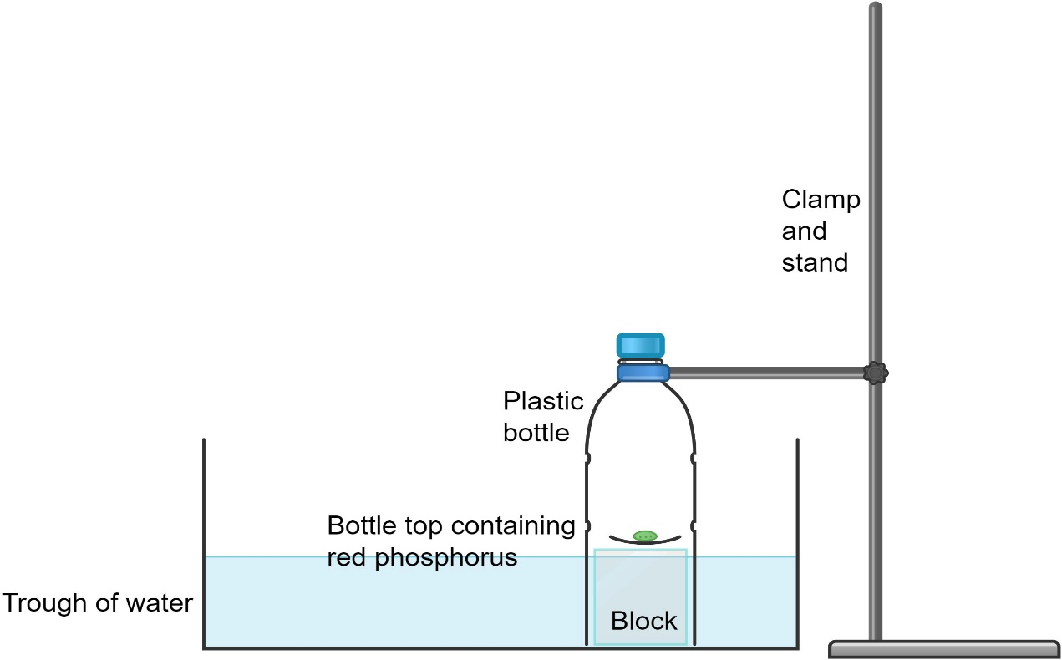
- Use the blowtorch or mini Bunsen burner to ignite the red phosphorus
- As soon as it is alight pick up the clamp and place the bottle over the burning phosphorus and either put the top on or push the rubber bung in.
This can’t be done before putting the bottle in the water due to air pressure effects.
- The phosphorus will continue burning and the water level inside the bottle will rise. It will lift up the bottle top but that’s fine as it will float on the surface.
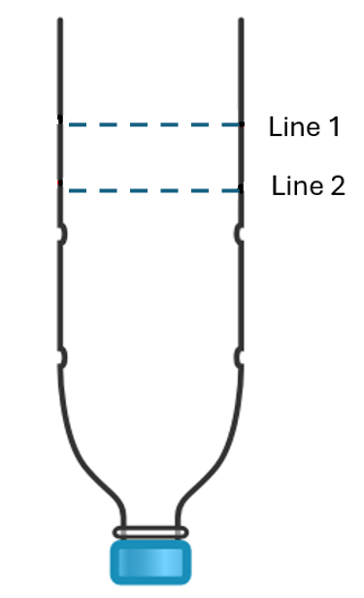
- Leave the apparatus for at least 10 minutes or until the cloudiness has dissipated, during which time the phosphorus pentoxide dissolves in the water.
- Mark the new water level on the outside of the bottle.
Strictly speaking, this should be done at the same atmospheric pressure as for the initial mark, so add water to the trough until levels inside and outside the bottle are equal before applying the mark.
- To find the volumes:
Remove the bottle from the clamp, and make sure the bung is in or the top is on.
  - Turn the bottle upside down and pour water in until it reaches the first mark you made (the one that is now higher up – Line 1 on the diagram)
  - Pour this water into a measuring cylinder. The volume is equal to that of the total amount of air in the bottle at the start.
  - Turn the bottle back upside down and add water again, this time to the second line you made, (the one that is now lower – Line 2 on the diagram)
  - Again, pour the water into the measuring cylinder. This is the volume of the air remaining after the burning – effectively the volume of nitrogen.
  - To find the volume of oxygen, subtract the second figure from the first one.

The Chemistry
This is fairly straightforward. Phosphorus burns in air, reacting with the oxygen to form phosphorus pentoxide.
P₄+5O₂ P₄O₁₀
Strictly speaking this is the equation for the burning of white phosphorus which exists in tetrameric molecules. Red phosphorus is an amorphous solid network but the equation is normally given in this form.
The phosphorus oxide is referred to as phosphorus pentoxide after the empirical formula P₂O₅.
This oxide reacts with water to form phosphoric acid.
P₄O₁₀ + 6 H₂O 4 H₃PO₄
So as the phosphorus burns, it reacts with oxygen in the air and the product formed dissolves in the water. Thus the volume of the air decreases in proportion to the amount of oxygen.

Disposal.
Place the beer-bottle top on a tripod and gauze in a fume cupboard and heat strongly with a Bunsen burner (or use the blowtorch) to burn unreacted phosphorus.
Allow it to cool and then place it into a beaker of water. Leaver for several hours - preferably overnight. The phosphoric acid solution produced is very dilute and can be washed to waste with plenty of cold water.

Safety
The phosphorus itself is not excessively hazardous.
The only significant problem comes from the highly corrosive fumes of phosphorus pentoxide that are produced in the experiment.
Carry the burning part out in a fume cupboard and the demonstrator should wear eye protection as well.

