

Separation and identification of amino acids using paper chromatography
Curriculum links
Paper chromatography of amino acids is one of the practical learning activities suggested in Higher Biology [1]. Distinguishing between different amino acids using chromatography is also included under the mandatory course key area ‘Laboratory techniques for biologists’ in the ‘Cells and Protein’ Unit of Advanced Higher Biology [2].

Background
Chromatography is used to separate mixtures of substances into their components. All forms of chromatography work on the same principle and involve a stationary phase (a solid, or liquid supported on a solid) and a mobile phase (a liquid or a gas solvent). The mobile phase dissolves the components of the mixture and flows through the stationary phase. The components of the mixture interact in subtly different ways (related to physical characteristics such as molecular size, shape and solubility) with the mobile and stationary phases. Substances that interact strongly with the stationary phase will travel more slowly than those substances that have less interaction. This means that the different components of a mixture become separated in a given time.

In paper chromatography, the stationary phase is a very uniform absorbent paper. The mobile phase is a suitable liquid solvent or mixture of solvents.

In both paper and thin-layer chromatography (TLC) a sample is applied as a spot near one end of the sheet or plate by microsyringe or microcapillary. The sheet is allowed to dry fully and is then transferred to a glass tank containing a shallow layer of appropriate solvent. The solvent will travel up through the paper, or sheet, dissolving the sample and carrying it with it. Some compounds will travel almost as far as the solvent leaving a visible spot on the sheet; some will stay closer to the base line. When the solvent front has travelled 80 – 90% of its length the sheet is removed from the solvent and allowed to dry. In some cases spots may need to be rendered visible by reacting them with a substance which produces a coloured product.

The movement of a substance can be expressed in terms of its ‘relative front’ (R_{F} value) relative to the solvent.
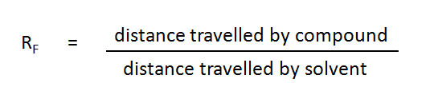

Ascending chromatography of amino acids
A mixture of unknown amino acids can be separated and the amino acids identified by using paper chromatography. The positions of the unknown amino acids can be compared to those of known amino acids on the same chromatogram. These positions can be detected by spraying the chromatogram with ninhydrin which reacts with amino acids producing coloured spots.

The following protocol has been adapted from a protocol produced by Dart Publishing, 1996

Please read the accompanying health and safety guidelines prior to starting this procedure.

Equipment per pair
- amino acid samples: asparagine, lysine, proline, tryptophan, leucine
- mixture of unknown amino acid samples
- chromatography tank (a large glass beaker will suffice)
- clingfilm, or tank lid
- 50 cm³ chromatography solvent
- chromatography paper (20 cm x 20 cm)
- capillary tubes
- access to a fume cupboard
- ninhydrin spray
- disposable gloves
- safety goggles
- pencil and ruler
- hair dryer, or oven at 105⁰C

Method
- Place 50 cm³ of chromatography solvent in the chromatography tank and cover the tank with a lid, or clingfilm. Leave for 15 minutes to allow the atmosphere in the tank to become saturated. Make sure the tank is placed where it can be left undisturbed.
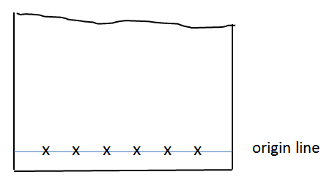
- On a piece of chromatography paper, draw a pencil line 2.5 cm from the bottom edge. It is essential that the solvent level is below this line. Place 6 crosses on the line each 2.5 cm apart. [Fig 1}These will be the ‘origins’ for the amino acid sample. Wear gloves when handling the paper because sweat contains amino acids which will contaminate the chromatogram.

Figure 1

- Below the cross on the right mark ‘mix’. Below the other 5 crosses mark which amino acid will be used (e.g. asp, lys, pro, try, leu).
- Place the paper on a dry, clean area of workbench. Using a clean capillary tube for each sample, spot a drop on to the appropriate origin. Allow the drops to dry between each application and apply 3 drops to each origin.
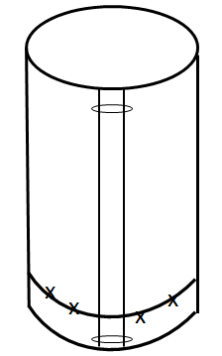
- Form the paper into a cylinder with the origin line at the bottom. Staple the at the top and bottom edges to hold the cylinder in place – make sure the edges are not touching. [Fig 2]

Figure 2

- Lower the paper cylinder into the solvent in the chromatography tank. Take care that the lower end is horizontal as it touches the solvent and that the paper does not touch the sides of the tank.
- Replace the lid of the tank and allow the solvent to run for about 2 hours. Don’t allow the solvent front to reach the top of the paper.
- Wear gloves to remove the paper from the tank taking care only to touch the edges. Carefully remove the staples and quickly mark the solvent front with a pencil. Hold the paper in a fume cupboard until the solvent has evaporated.
- Attach the paper to a clamp in the fume cupboard and taking great care spray lightly with ninhydrin.
- Using a hair dryer carefully dry the chromatogram while it is still in the fume cupboard. Or, place the chromatogram in the oven at 105⁰C for 2 minutes.
- Once the chromatogram is dry, the amino acids will show up as coloured spots. These will fade in time, so outline them in pencil.

Results
It should be possible to calculate the R_{F} values for each of the amino acids. These are the distance moved by the compound relative to the solvent front. [Fig 3] They are always the same for a particular compound relative to the solvent front if the same mobile and stationary phases are used. R_{F} values can therefore be used to identify the compounds in a mixture of unknowns.

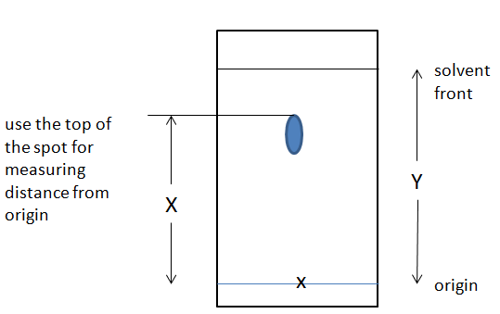

Figure 3

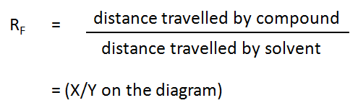

Safety
Precautions should be taken when preparing the chromatography solvent which contains ammonia solution and ethanol. Precautions are also necessary when using ninhydrin. Ammonia solution (.880) is corrosive and gives off toxic fumes. Ethanol is highly flammable. Ninhydrin is harmful if swallowed and is also a skin, eye and respiratory irritant. Ninhydrin is NOT a carcinogen. The amino acids listed in the protocol are all of low hazard (if using any other amino acids, check the associated hazards).

A risk assessment should be carried by the technician preparing the chemicals and by the teacher supervising pupils carrying out this activity.

- Goggles (BS EN 166 3) and nitrile gloves should be worn by the technician for handling ammonia in the preparation of the chromatography solvent and the solvent should be prepared in a fume cupboard.
- Keep ethanol and the prepared chromatography solvent away from sources of ignition.
- Goggles and nitrile gloves should be worn by pupils when setting up the chromatogram. Pupils should be reminded to keep the solvent away from sources of ignition and to keep the lid off the bottle of solvent and chromatography tank for as short a time as possible. Once the chromatography is underway there is little hazard, but care should be taken when filling and emptying chromatography tanks.
- Ninhydrin should be sprayed in a fume cupboard and pupils should either be supervised following a demonstration, or teacher, or technician should spray chromatograms. In each case nitrile gloves and goggles should be worn.
- We suggest placing a cardboard box on its side within the fume cupboard, and hanging chromatograms inside this, or in front of large sheets of paper to absorb the ninhydrin spray.
- If a ninhydrin dip is used instead of a spray, it can be done in a well-ventilated room.
- Some amino acids are irritant and harmful. Those listed in the protocol are of low hazard. If amino acids other than those listed are to be used, the hazards need to be checked and taken account of in the risk assessment.

Equipment per group
- Amino acid samples (0.25% in distilled water) asparagine, lysine, proline, tryptophan, leucine.
- “Unknown” sample containing a mixture of 3 of the amino acids above, we suggest proline, asparagine and leucine.
- Chromatography tank and lid – a large beaker will suffice.
- Clingfilm, or foil to act as a lid for the tank.
- 50 cm³ chromatography solvent: 80% ethanol, 10% 0.880 ammonia, 10% distilled water by volume.
- Chromatography paper ~ 20 cm x 20 cm.
- 6 x capillary tubes (1 for each sample).
- Safety goggles and nitrile gloves.
- Access to a fume cupboard.
- Access to ninhydrin spray.
Resources
Prices at December, 2015
From Scientific and Chemical :
Ninhydrin spray (240ml): £58.46
Chromatography paper (20x20cm): £33.75
Amino acid kit (contains 20 amino acids): £63.71
From Timstar
Capillary tubes (pk 100): £3.64

References

- SQA (2014) Higher Human Biology Course Support Notes - can be downloaded at: www.sqa.org.uk/files_ccc/CfE_CourseUnitSupportNotes_Higher_Sciences_Biology.pdf
- SQA (2014) Advanced Higher Biology Course Support Notes - can be downloaded at:
http://www.sqa.org.uk/files_ccc/AHCUSNBiology.pdf

