

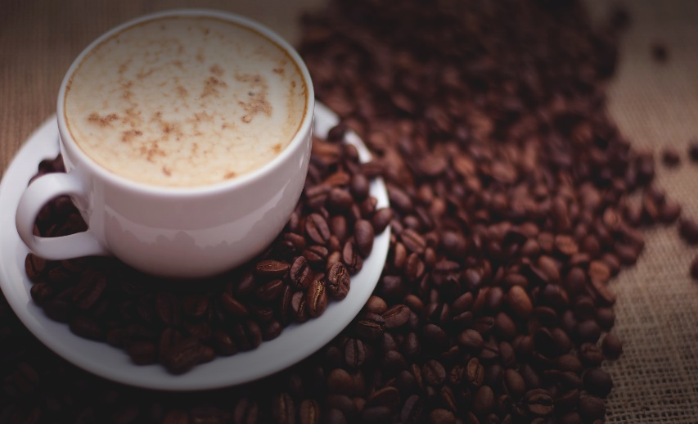

Pupil

Experiment

Extraction of Caffeine from tablets

Teacher/Technician Guide

Introduction
Tea and coffee are two of the most commonly consumed drinks in the world. The active ingredient that makes them valuable to humans is caffeine. Caffeine is an alkaloid, a class of naturally occurring compounds having the properties of an organic amine base.

Product | Caffeine (mg/L)
Coffee, espresso | 1,691–2,254
Filter coffee | 555–845
Red Bull | 320
Tea | 124–418
Coca-Cola | 96
Coffee, decaffeinated | 24–72

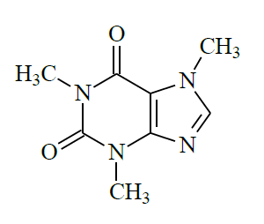
Caffeine is found in over 60 plant species. It belongs to a family of naturally occurring compounds known as xanthines. The xanthines, which come from plants, are possibly the oldest known stimulants. Caffeine is the most powerful xanthine in its ability to increase alertness, put off sleep and to increase one’s capacity for thinking. Caffeine is also a vasodilator (relaxes the blood vessels) as well as a diuretic (increases urination).

Extraction of caffeine from tea leaves is quite a common experiment at Advanced Higher level – usually as a project.
Caffeine does not exist alone in tea leaves; the leaves are mainly cellulose, pigments and chlorophylls, and tannins. Tannins are phenolic compounds of high molecular weight. The acidic phenols of tannins can complex with metals like calcium to form solid precipitates.
Because of the various contaminants that need to be removed, extraction from tea leaves is a little more complex and time consuming so we are going to make the extraction from caffeine tablets.
Most traditional caffeine extractions specify chloroform (trichloromethane) or dichloromethane. Chlorinated hydrocarbons are not good for the environment and so we are using a greener process to extract the caffeine.
There are a few options but we think the best one is ethyl ethanoate (ethyl acetate) for the extraction.
The recrystallisation is simply done using hot ethanol.

Experiment

You will need
Caffeine pills (each pill contains 50mg caffeine) | 2 g Sodium carbonate
~8 g Anhydrous sodium sulphate | 50 cm³ Ethyl Ethanoate
50 cm³ Ethanol | Separating funnel
250 cm³ beakers (x3) | 50/100 cm³ Measuring Cylinder (x2)
Bunsen burner, tripod & gauze or hotplate | Evaporating dish / crystallising basin
Filter funnel & paper | Small Buchner / Hirsch funnel, filter paper and vacuum pump.
Ice bath and ice | Balance
Spatula | Access to a kettle
Stirring rod | 100 cm³ Conical flask and stopper (x2)
100 cm³ beaker (x2) | Cotton wool
Pasteur pipettes | Clamp and stand

Instructions
- Add 50 cm³ of boiling water (from a kettle) to 10 caffeine pills in a 250 cm³ beaker.
- Continue to boil, over a Bunsen burner or on a hotplate, for up to 5 minutes, stirring occasionally to ensure the pills have disintegrated.
- Filter off the insoluble magnesium stearate into a 250 cm³ beaker.
- Add 2g sodium carbonate and dissolve, stirring if needed.
This is to make sure that the caffeine remains in the free base form (that is, to prevent it from reacting with any acids that may be present and form a cation)
- Cool the solution down in an ice bath.
- Transfer to a separating funnel and extract the caffeine with ethyl ethanoate (twice with 20 cm³ and then once with 10 cm³).
Do not shake too hard (a swirling action is better) as there is the possibility of creating an emulsion. This may separate on standing but it could take a long time.
- Combine the ethyl ethanoate extracts in a 100 cm³ conical flask and add 8g anhydrous sodium sulphate to dry the solvent.
- Preweigh the crystallising basin and record the value.
- Decant the now dry solvent into an evaporating/crystallising basin. Transfer this to the fume cupboard to evaporate
This will ensure that the solvent has all evaporated off before the next part of this experiment.

The experiment can be paused here and the recrystallisation can take place on another day if desired.

Recrystallisation of caffeine
The crude caffeine, or the caffeine sample provided can be purified by sublimation or by recrystallization. Several solvents can be used for this but the easiest and cheapest is ethanol.
- Weigh the crude product.
- Dissolve the crude caffeine in a small amount of ethanol
  - Put the container with the crude caffeine in on a hotplate, add 20 cm³ of ethanol and warm.
  - Swirl/stir to dissolve the caffeine. If it doesn’t dissolve, add a bit more ethanol until it has.
- Allow to cool slowly in a corked conical flask. After recrystallization has occurred, cool the flask further in an ice bath.
- Weigh your filter paper and record the mass.
- Filter the chilled solution in a small Buchner or Hirsch funnel.
- Dry in air and weigh.

Identification
Caffeine sublimes so you cannot get a boiling point. It is possible to carry out Thin Layer Chromatography (TLC) on it.
You will need
TLC sheet cut to size if needed | Ethanol
TLC solvent* | Iodine crystals
1 beaker/ bottle for developing TLC plate | 1 glass bottle with lid for visualisation of TLC plate
Hair dryer
* 6 parts Water: 1 part 2 mol l⁻¹ ammonia
Method
- Dissolve a small amount of caffeine in hot ethanol and spot the TLC plate with it: a small spot near bottom of sheet.
- Add the solvent to the beaker/bottle and run the TLC plate.
- When complete remove the plate from the beaker and dry with a hair dryer.

Visualisation
Place a few iodine crystals and the dry TLC plate in a small bottle and tighten the lid. The iodine fumes will react with the caffeine to leave a spot.
The distance travelled can be compared with pure caffeine.
To speed up the process the bottle can be placed in a beaker of hot water.
NB circle the spot with a pencil after removing from the visualisation bottle as the iodine stain does fade over time.

Safety
Ethyl Ethanoate is a highly flammable and is an irritant to the respiratory tract, mucous membranes, eyes and gums. Keep away from sources of ignition.
Ethanol is highly flammable. Keep away from sources of ignition.

Technician Guide

Each group will need
10 Caffeine pills (each pill contains 50mg caffeine)* | 2 g Sodium carbonate
~8 g Anhydrous sodium sulphate** | 50 cm³ Ethyl Ethanoate
50 cm³ Ethanol | Separating funnel
250 cm³ beakers (x3) | 50/100 cm³ Measuring Cylinder (x2)
Bunsen burner, tripod & gauze or hotplate | Evaporating dish / crystallising basin
Filter funnel & paper | Small Buchner / Hirsch funnel, filter paper and vacuum pump.
Ice bath and ice | Balance
Spatula | Access to a kettle
Stirring rod | 100 cm³ Conical flask and stopper (x2)
100 cm³ beaker (x2) | Cotton wool
Pasteur pipettes | Clamp and stand
For TLC
TLC sheet cut to size if needed | Ethanol
TLC solvent*** | Iodine crystals
1 beaker/ bottle for developing TLC plate | 1 glass bottle with lid for visualisation of TLC plate
Hair dryer

* More or fewer can be used but if there are many fewer, the yield will be too low.
** The exact amount will vary – give then 8-10g
*** 6 parts water: 1 part 2 mol l⁻¹ ammonia

Note 1: If the caffeine is extracted from other sources, like tea, there could well be impurities present. In this case rapidly filter the hot solution through a small plug of cotton wool in a Pasteur pipette before step 3.
Note 2: To get a purer sample (when extracting from tea for instance), a final wash with ice-cold ethanol is a good idea. But this will reduce the yield.

Instructions

Extraction
- Add 50 cm³ of boiling water (from a kettle) to 10 caffeine pills in a 250 cm³ beaker.
- Continue to boil, over a Bunsen burner or on a hotplate, for up to 5 minutes, stirring occasionally to ensure the pills have disintegrated.
- Filter off the insoluble magnesium stearate into a 250 cm³ beaker.
- Add 2g sodium carbonate and dissolve, stirring if needed.
- Cool the solution down in an ice bath.
- Transfer to a separating funnel and extract the caffeine with ethyl ethanoate (twice with 20 cm³ and then once with 10 cm³).
Do not shake too hard (a swirling action is better) as there is the possibility of creating an emulsion. This may separate on standing but it could take a long time.
- Combine the ethyl ethanoate extracts in a 100 cm³ conical flask and add 8g anhydrous sodium sulphate to dry the solvent.
- Preweigh the crystallising basin and record the value.
- Decant the now dry solvent into an evaporating/crystallising basin. Transfer this to the fume cupboard to evaporate
This will ensure that the solvent has all evaporated off before the next part of this experiment.
Recrystallisation of caffeine
The crude caffeine, or the caffeine sample provided can be purified by sublimation or by recrystallization. Several solvents can be used for this but the easiest and cheapest is ethanol.
- Weigh the crude product.
- Dissolve the crude caffeine in a small amount of ethanol
  - Put the container with the crude caffeine in on a hotplate, add 20 cm³ of ethanol and warm.
  - Swirl/stir to dissolve the caffeine. If it doesn’t dissolve, add a bit more ethanol until it has.
- Allow to cool slowly in a corked conical flask. After recrystallization has occurred, cool the flask further in an ice bath.
- Weigh your filter paper and record the mass.
- Filter the chilled solution in a small Buchner or Hirsch funnel.
- Dry in air and weigh.

Identification
Caffeine sublimes so you cannot get a boiling point. It is possible to carry out Thin Layer Chromatography (TLC) on it.
Method
- Dissolve a small amount of caffeine in hot ethanol and spot the TLC plate with it: a small spot near bottom of sheet.
- Add the solvent to the beaker/bottle and run the TLC plate.
- When complete remove the plate from the beaker and dry with a hair dryer.

Visualisation
Place a few iodine crystals and the dry TLC plate in a small bottle and tighten the lid. The iodine fumes will react with the caffeine to leave a spot.
The distance travelled can be compared with pure caffeine.
To speed up the process the bottle can be placed in a beaker of hot water.
NB circle the spot with a pencil after removing from the visualisation bottle as the iodine stain does fade over time.

