Photosynthesis
Aim: To investigate the effect of light intensity on photosynthesis.
Background:
Photosynthesis is a complex biochemical process that takes place in chloroplasts of plants. It involves the Light Reactions and Carbon Fixation. During these processes, light energy is absorbed by plant pigments to split water into oxygen and hydrogen. Hydrogen, carbon dioxide and energy are required, in a series of enzyme-catalysed reactions, to produce glucose for the plant cells. Various factors are known to affect the rate of photosynthesis, including the concentration of carbon dioxide, temperature and light intensity. Different plant species will also photosynthesise at different rates.

In this protocol, different plant species are used to compare photosynthetic rates. Bladderwrack, a common brown seaweed readily available on Scottish shorelines, will be compared to Egeria najas (a fast growing aquatic pondweed) and a freshwater alga called Scenedesmus quadricauda.

As photosynthesis proceeds, carbon dioxide is used up by the plant. This will increase the pH of the bathing solution (it will become more alkaline). Bicarbonate indicator can be used as the bathing solution for plants in photosynthesis investigations and then used to visualise a change in pH. The colour chart below can be used to estimate the pH of the indicator.
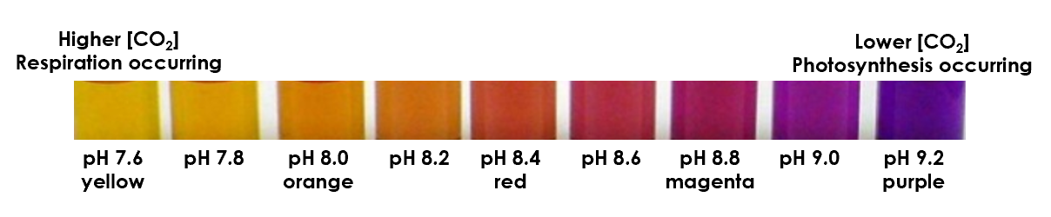

Experiment 1
Materials required (per pair):
Choice of bladderwrack, algae beads, E. najas | Neutral density filters (209 & 210 transmit 51% & 24% light, respectively)
5 x bijou bottles | Black paper
2x 25 cm³ bicarbonate indicator | 50 cm³ beaker (1/2 full of distilled water)
Scissors | 5x cuvettes
Forceps | 3 cm³ dropping pipettes
Access to a balance | Marker pen
Weigh boat | Access to fluorescent tube light
Colorimeter | Stopwatch

Pair | Plant choice
1 | Seaweed
2 | Egeria
3 | Algae
4 | Seaweed
5 | Egeria
6 | Algae
7 | Seaweed
8 | Egeria
9 | Seaweed
10 | Algae
Note: A concentrated suspension of Scenedesmus was grown. An equal volume of the culture was mixed with 2% sodium alginate, before passing through a 10 cm³ syringe and allowing the mixture to drop into 2% calcium chloride.

Method - in pairs
- Line up 5 empty Bijou bottles (each bottle has a volume of approximately 6 cm³). Rinse the first bottle with approximately 2 - 3 cm³ of bicarbonate indicator and transfer the indicator to the second bottle. Repeat until all 5 bottles have been rinsed. This step is to ensure that there are no contaminants in the containers – in school, test tubes might be used instead – this step allows learners to check that their containers are clean.

- Label the lids of the bottles with your initials and the light intensity to be used:
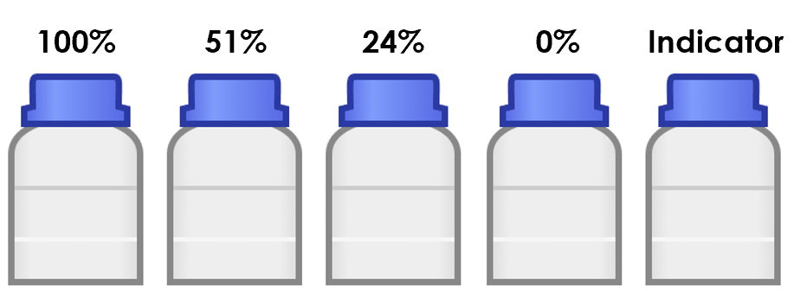
- Prepare your plant samples.
  - Seaweed: Cut 4 pieces 4 cm in length, avoiding air bladders.
  - Egeria: Cut 4 pieces each 4 cm in length.
  - Algae: Isolate 10 algae beads for each bottle – 40 in total.
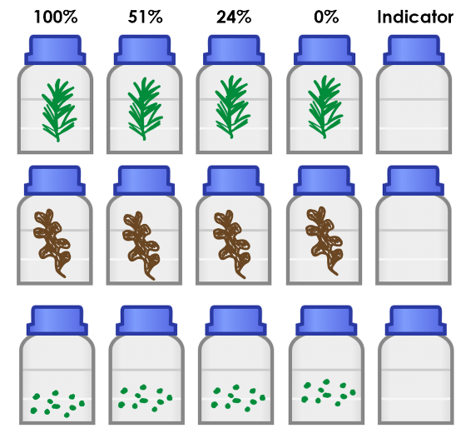
- Place your prepared plant sample into 4 of the rinsed Bijou bottles.

- Fill all 5 Bijou bottles with bicarbonate indicator and write your initials on the lid.

- You are provided with 3 pre-formed filter sleeves which will allow either 51%, 24% or 0% of light to be transmitted. Place these filters over 3 of your Bijou bottles containing plant material.
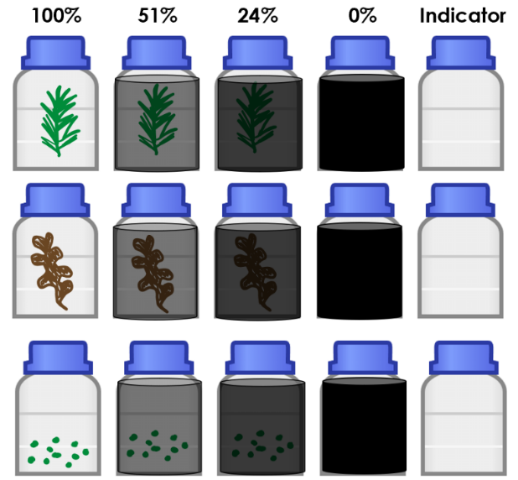
- The 2 remaining bottles – one containing plant + indicator and one containing just indicator - will not be covered.

- Line all 5 bottles in front of the lamps and leave for 25 minutes.

- Thoroughly mix the contents of each Bijou bottle.

Recording results – 2 options
Options 1 – using the colour chart to estimate pH
Light intensity (%) | pH of indicator
 | Seaweed | Algae | E. najas
0
24
51
100

Option 2 – using the colorimeter
The controls for the colorimeter are relatively simple:
 | Power switch turns the unit on. The unit switches off after about 2 minutes to conserve battery power.
CAL | Calibrates the unit to 0.000 absorbance or 100.0% transmittance
RGB | Switches between the red, green and blue light sources
A/T | Switches display between absorbance and transmittance

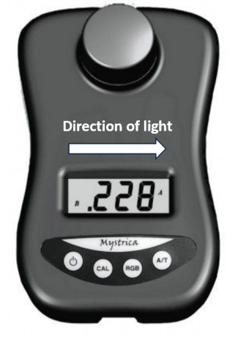
- Switch on the colorimeter. Select the green diode by pressing RGB until ‘G’ appears in the top left-hand side of the display screen.

- Select absorbance by pressing A/T until A appears in the top right-hand side of the display screen.

- Place a cuvette of distilled water into the colorimeter. Press ‘CAL’ to zero the colorimeter.

- Empty the cuvette and replace with the indicator from the Bijou bottle which did not contain any plant material and measure the absorbance.

- Measure and record the absorbance of the 4 remaining Bijou bottles starting with 0% light transmitted.

Raw data
Light intensity (%) | Absorbance of light by indicator
 | Seaweed | Algae | E. najas
0
24
51
100

Absorbance of indicator only:______________________

Corrected / processed data
The absorbance of the indicator only must be subtracted from all absorbance values to account for the initial absorbance of the indicator in the absence of biochemical reactions by the plant.
An alternative suggestion might be to “blank” the colorimeter using indicator only; however, as a result of potential respiration taking place under some light conditions, the pH of the indicator might decrease, resulting in a “more yellow” indicator colour compared to the control. This would read as “neg” on the colorimeter. By taking a reading of the indicator, a negative value can be presented if respiration has occurred.

Light intensity (%) | Corrected absorbance of light by indicator
 | Seaweed | Algae | E. najas
0
24
51
100

Experiment 2: Microscale photosynthesis
Materials required (per pair):
dimple tile | Squares of neutral density filter (51% and 24%)
Choice of seaweed (2 cm) / algae beads (x40) / Egeria najas (2 cm) | Square of black paper
Light source | 2.5 cm³ bicarbonate indicator
P1000 pipette + tips | 1 cm³ plastic pipettes
spoon | Forceps
Bicarbonate indicator colour chart

Method - in pairs
  - Prepare your plant samples:
    - Seaweed: transfer 1 cm seaweed to 4 wells of the dimple tile.
    - Egeria: transfer 1 cm Egeria to 4 wells of the dimple tile.
    - Algae: Use a spoon and forceps to transfer 10 algae beads to 4 wells of the dimple tile.

  - Use the P1000 to add 0.5 cm³ bicarbonate indicator to the 4 wells containing plant material + an empty well.
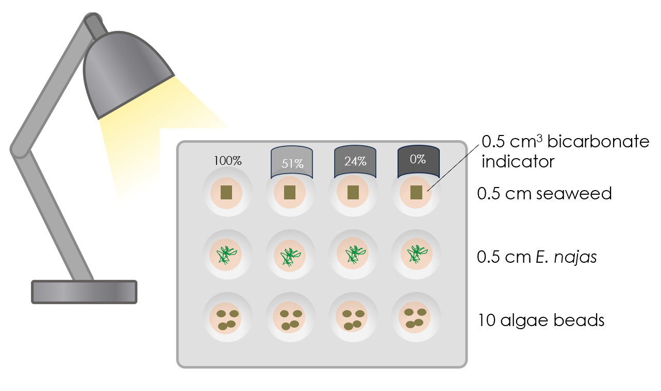

  - Add the following filters to each well:
    - Well 1: no filter (100% light reaching the plant)
    - Well 2: 51% filter
    - Well 3: 24% filter
    - Well 4: black paper
    - Well 5: no filter; no plant

- Place the dimple tile under a lamp and leave for 30 minutes.

- Use a pipette to transfer the indicator to fresh wells on the dimple tile.

- Use the bicarbonate indicator chart to record the pH of the indicator.
Results
Light intensity | pH of the indicator
 | seaweed | E. najas | algae
0
24
51
100

The pH of the indicator in the absence of plant was: ____________________________

