Transpiration
Aim: To investigation the effect of [wind speed / temperature / surface area / humidity] on rate of transpiration.

Materials – demonstration only
1 cm³ graduated pipette | Gratnell tray of water
40 cm length 3 mm diameter silicone tubing | Leafy stem, e.g. horse chestnut leaf
10 cm³ syringe | Secateurs / strong scissors
Vaseline | Parafilm
Retort stand with 2 retort clamps

Method:
- Fill a large tray with water and submerge the graduated pipette. Tip the pipette slightly on an angle until you see a flow of air bubbles escaping from the pipette. Use the syringe to push through any trapped air bubbles.

- Repeat Step 1 with a length of silicone tubing. Leave both the graduated pipette and tubing submerged.

- Very quickly collect a leafy stem, minimising its time out of water. Submerge the stem in the tray of water – try to keep the leaves out of the water.

- Using a sharp pair of scissors, scalpel or secateurs, cut the end of the stem under the surface of the water at a slight angle. The cutting tool will depend on the diameter of the stem – our silicone tubing has 3 mm internal diameter so the stem will be cut with scissors but can require a bit of force.

- Continuing to work under the surface of the water, insert the stem into the silicone tubing.

- Insert the other end of the tubing to the neck of the graduated pipette.

- Under the surface of the water, add a layer of Vaseline to any connecting points, i.e. between the tubing and the stem, and between the tubing and the graduated pipette.
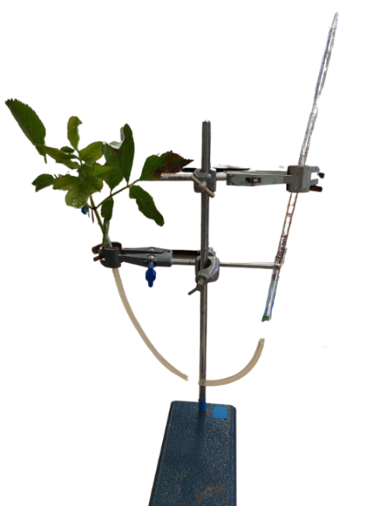
- Working in pairs, secure the potometer in the retort stand with the graduated pipette secured in one retort clamp and the stem secured in the other clamp.

- Record the level of the water in the glass pipette at time 0 s.

- Leave the potometer for a period of time, regularly noting the water level. Return to the experiment throughout the day to record readings. Share readings with other groups. Movement of water should be expected within 15 minutes.

- Control: The same experimental set-up can be established with a “fake” stem included. This will show the movement of water attributed to evaporation to the atmosphere.

Important observations to make:
- Depending on how secure the seal is between the plant and the tubing, leaks can happen at this connection point. If this is the case, the apparatus will not yield results and a few stem of larger diameter, or tubing with a smaller diameter, will be required. Sometimes Vaseline and parafilm can be used to provide a better seal.

This experiment will link nicely to the microscopy activity later, looking at stomata.

Time (min) | Volume of water in the graduated pipette (cm³) | Rate of transpiration (cm³ / min)
0
Rate of transpiration over experiment (cm³ / min)

Independent Variables:
- Temperature – set up the apparatus in different rooms, recording the temperature of the room using a thermometer.

- Wind speed – set up the apparatus with or without a fan (or using a fan with variable speeds). An anemometer can be used to quantify the air movement.

- Humidity – a water diffuser can be used to spray the leaves. The number of sprays used can be adjusted to alter the humidity. This will slow down the rate of transpiration so time considerations should be accounted for if learners choose this variable.

- Surface area of leaf – this can be measured using a piece of graph paper and drawing around the leaf.

