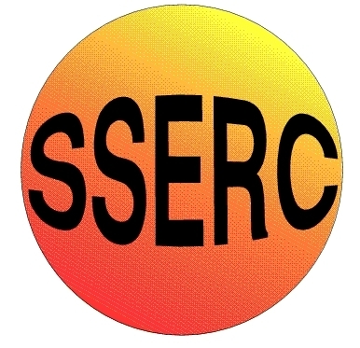
SSERC Risk Assessment (revised version November 2009)
(based on HSE ‘5 steps to risk assessment’)

2 Pitreavie Court, South Pitreavie Business Park, Dunfermline KY11 8UB
tel : 01383 626070 fax : 01383 842793
e-mail : sts@sserc.org.uk web : www.sserc.org.uk

Activity assessed
Date of assessment
Date of review (Step 5)
School
Department

Step 1 | Step 2 | Step 3 |  | Step 4
List Significant hazards here: | Who might be harmed and how? | What are you already doing? | What further action is needed? | Action by whom? | Action by when? | Done
Ammonia solution (.880) is corrosive and gives off toxic fumes. | Technician by inhalation or from splashes while preparing the chromatography solvent | Prepare the solvent in a fume cupboard.  Wear goggles (BS EN166 3) and nitrile gloves.
Ethanol is highly flammable. The same is true of the 80% ethanol used in the extraction. | Technicians, teachers or pupils if solvent ignites. | Keep away from sources of ignition.
The chromatography solvent is flammable and corrosive (containing 1.81M Ammonia) | Pupils by splashes while carrying out TLC. | Wear goggles (BS EN166 3) and possibly nitrile gloves. Keep the lid off the bottle for as short a time as possible. Keep away from sources of ignition.
Butan-1-ol is flammable, harmful if ingested, a skin irritant and corrosive to the eyes. | Technician by splashes while preparing the ninhydrin solution. | Wear goggles (BS EN166 3) and possibly nitrile gloves. Work in a fume cupboard and keep away from sources of ignition.
Ninhydrin is harmful if swallowed and a skin/eye respiratory irritant.  The main hazards are likely to come from the solvent, often Butan-1-ol (see above)  If it is in a different solvent, check the hazards. | Pupils/teacher by inhaling fumes/droplets while spraying chromatogram. | Spray the plate in a fume cupboard.  Wear eye protection and gloves. Keep away from sources of ignition.
The amino acids in the protocol are all of low hazard.

Description of activity:

Additional comments:

If the ninhydrin solution is bought ready-made, check for the specific hazards. (Ninhydrin is NOT a carcinogen).

Once the chromatography is under way in the tank, there is little hazard but care should be taken while filling and emptying it.

A few amino acids are irritant or harmful. If ones other than those listed are used technicians should check the hazard. The solutions will all be of low hazard.

We suggest using a cardboard box (or large sheets of paper) inside the fume cupboard to contain the spray from ninhydrin

If a ninhydrin dip is used instead of a spray, it can be done in a well-ventilated classroom.

