

|  |
| --- |
| Chemical Demonstrations  **CfE Level 3**  Through experimentation, I can identify indicators of chemical reactions having occurred. I can describe ways of controlling the rate of reactions and can relate my findings to the world around me.  SCN 3-19a  *(possible links elsewhere for some of the reactions)*  **National 4** - Chemical changes and structure  Atomic Structure and Bonding related to properties of materials |
| Iron sulphur reaction |

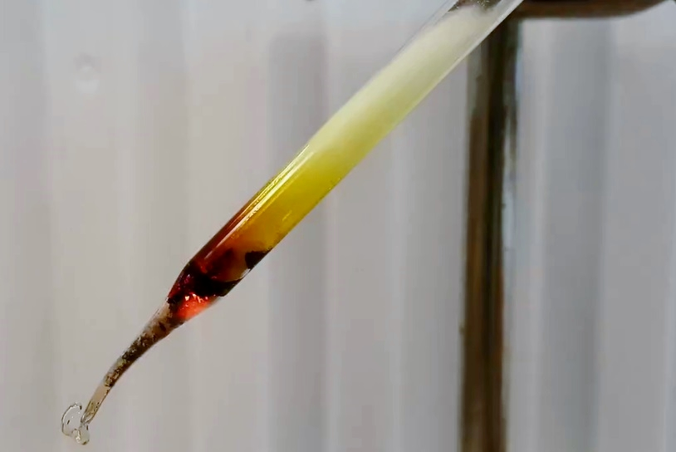

**Introduction**

This version of the experiment is only suitable as a teacher demonstration. There is, however, a microscale version that can safely be carried out by learners.

There are many forms of iron sulphide, it is not pure FeS.

Sulphur can dimerise (-S-S-) and form FeS2. There are mixed oxidation forms such as Fe3S4 and this version is ferromagnetic, just like some forms of Fe3O4. And no doubt not all the iron atoms have not reacted with sulphur but are inserted in the lattice structure of iron sulphide (known as [interstitial](http://en.wikipedia.org/wiki/Non-stoichiometric_compound)).

Therefore text books are not correct so say the product is not magnetic. It is and only by making a very weak magnet can a small difference be seen and that is not always successful..

**Health & Safety**

Wear eye protection and work in a well-ventilated laboratory.

Come Sulphur dioxide may be released during the experiment. Inhalation may exacerbate pre-existing conditions such as asthma. Plugging the mouth of the tube with mineral wool will significantly reduce the amount by preventing the release of sulphur fumes which can then catch fire – the source of the SO2.

Testing the iron sulphide produces hydrogen sulphide gas. This has an objectionable small and is very toxic.

**You will need**

|  |  |
| --- | --- |
| 2g of iron/sulphur mix (1.25g Fe : 0.75g S) | Small borosilicate glass test tube |
| Mineral wool (just enough to plug the test tube) | Bunsen burner |
| magnet | Paper clip |
| (hammer or other tool if tube needs to be broken) | Reaction vessel (‘blister from pack of tablets*) |
| 0.05 Mol l-1 lead or silver nitrate solution | 0.01 Mol l-1 copper sulphate(VI) solution |
| 0.0002 Mol l-1 potassium manganate(VII) solution | Tap water with a little Universal indicator present so it is green |
| 1 Mol l-1 Hydrochloric acid | 2 x petri dishes (small) |
| Pasteur pipettes | Laminated sheet (or paper sheet placed in plastic document wallet) See later in document |

* Try to get them from traditional ‘tablet’ shaped ones rather than capsules, as they will be more likely to be flat underneath and thus sit steadily

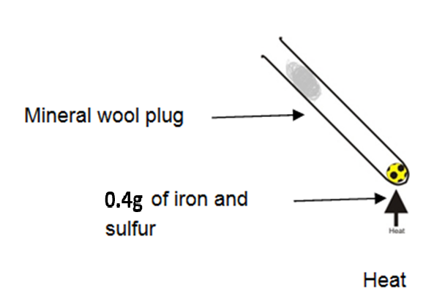**Reacting Iron and sulphur**

1. Place 2 g of the iron/sulphur mixture in a small borosilicate test tube. Keeping a small amount to test at the end.

*(Do not overfill it).*

1. Insert a mineral wool plug in the mouth of the tube. This prevents sulphur vapour from leaving the test tube and catching fire.
2. Clamp the tube (at the top) at roughly a 45° angle
3. Heat the powder mixture strongly with a roaring blue Bunsen flame.

*You will see a bright orange glow when the reaction starts – remove the Bunsen flame and you will see the glow persist for a while – demonstrating that it is not just due to the heat of the flame.*

1. Stop heating as soon as the reaction is completed.

*Once the glow has died down.*

1. Allow the apparatus to cool.
2. Tap the end of the test tube on a heat-proof mat to loosen the iron(II) sulphide.

*If it will not come out at all, wrap the tube in a cloth or paper towel (or newspaper) and hit it* ***gently*** *with a mallet or similar to break the tube*

**Testing the difference in chemistry between iron(II) sulphide and a mixture of iron and sulphur**

1. Remove the mineral wool plug and pour the iron(II) sulphide into a mortar. (or carefully separate samples from the broken glass.
2. Crush the iron(II) sulphide into a powder using a pestle and mortar..

**A Making a weak magnet and testing the magnetism of iron(II) sulphide**

1. Open up a paper clip.

2. Place a small amount of the original mixture of iron and sulphur on some paper. Bring the paper clip close. To the mixture.

3. Now take the magnet and run it down once the length of the paper clip.

4. Repeat step 2.

5. Use a spatula to transfer a small amount of the iron(II) sulphide mixture onto another piece of paper and repeat the test.

**B Testing iron(II) sulphide for chemical differences**

This part should be carried out in a fume cupboard (unless a microscale approach is used) as the hydrogen sulphide produced is toxic.

Add ~ 1 g of the unreacted iron/sulfur mixture into a test tube and a similar amount of iron sulphide into a different test tube.

Add 3-4 cm3 of 0.01 Mol l-1 lead nitrate (or 0.01Mol l-1 silver nitrate) solution into two other test tubes as test solutions.

Add ~ 2 cm3 of 1 Mol l-1 hydrochloric acid to either solid and fit a bung with a delivery tube.

Place the end of the delivery tube in the lead nitrate solution and allow any gas produced to bubble into the lead nitrate solution.

Repeat steps 3 & 4 for the other solid.

Lead or silver nitrate(V) or copper sulphate(VI) produce precipitates of lead/silver/copper sulphides which can looks “silvery” in reflected light.

H2S + Pb2+/Ag+/Cu2+ PbS/Ag2S/CuS + 2H+

As an alternative, you can use Potassium manganate(VII). In this case, solution goes clear as the manganate VII ion is reduced by hydrogen sulphide.

3H2S + 2KMnO4 3S + 2H2O + 2KOH + 2MnO2 (Acidic pH)

3H2S + 8KMnO4 3K2SO4 + 2H2O + 2KOH + 8MnO2 (Basic pH)

**Disposal**

The used test tube, broken or not, goes in the glass waste bin.

The iron(II) sulphide, can be placed in the normal refuse bin. As can any solid residues from the generation of H2S..

The solution from the reaction with HCl can be washed to waste with plenty of cold running water.

Any lead, silver or copper solutions need to be kept for uplift at a later date.

|  |  |  |
| --- | --- | --- |
| Wear eye protection.  Place 2 5cm Petri dishes, each with plastic blister pack from a set of tablets which will act as the reaction vessel.  You may prefer to carry out this procedure in a fume cupboard as the reaction is smelly. You will not be poisoned if it is done in the laboratory. | | |
|  | Add the following reagents to the small circles 1 to 4   1. 0.05M lead or silver nitrate solution 2. 0.01M copper sulphate(VI) solution 3. 0.0002M potassium manganate(VII) solution 4. Tap water with a little Universal indicator present so it is green 5. Into one reaction vessel, add a small quantity of iron/sulphur mixture and to the other, the solid after heating the mixture. Place the vessel into the dish. (Take a photograph of the dish if you wish) 6. Add 5 drops of 1 M hydrochloric acid to each of the vessels and immediately place the lid on the dish. |  |



Lead or silver nitrate(V) or copper sulphate(VI) produce precipitates of lead/silver/copper sulphides which can looks “silvery” in reflected light.

H2S + Pb2+/Ag+/Cu2+ PbS/Ag2S/CuS + 2H+

Potassium manganate(VII) solution goes clear as the manganate VII ion is reduced by hydrogen sulphide.

3H2S + 2KMnO4 3S + 2H2O + 2KOH + 2MnO2 (Acidic pH)

3H2S + 8KMnO4 3K2SO4 + 2H2O + 2KOH + 8MnO2 (Basic pH)

Tap water is acidified. Hydrogen sulphide is slightly soluble in water and acts as a weak acid, giving the hydrosulfide ion HS−.

H2S H+ + HS-