Measuring the refractive index of a liquid using a liquid prism of small refracting angle made using two microscope slides

Apparatus

* 3 glass microscope slides 1mm or 1.5mm in thickness,
* a dropping pipette,
* a plane mirror at least 75cm by 50cm,
* a clamp stand,
* a 15cm transparent ruler,
* a 10cm by 10cm piece of cardboard,
* a 10cm by 10cm square of white paper,
* a metre stick.

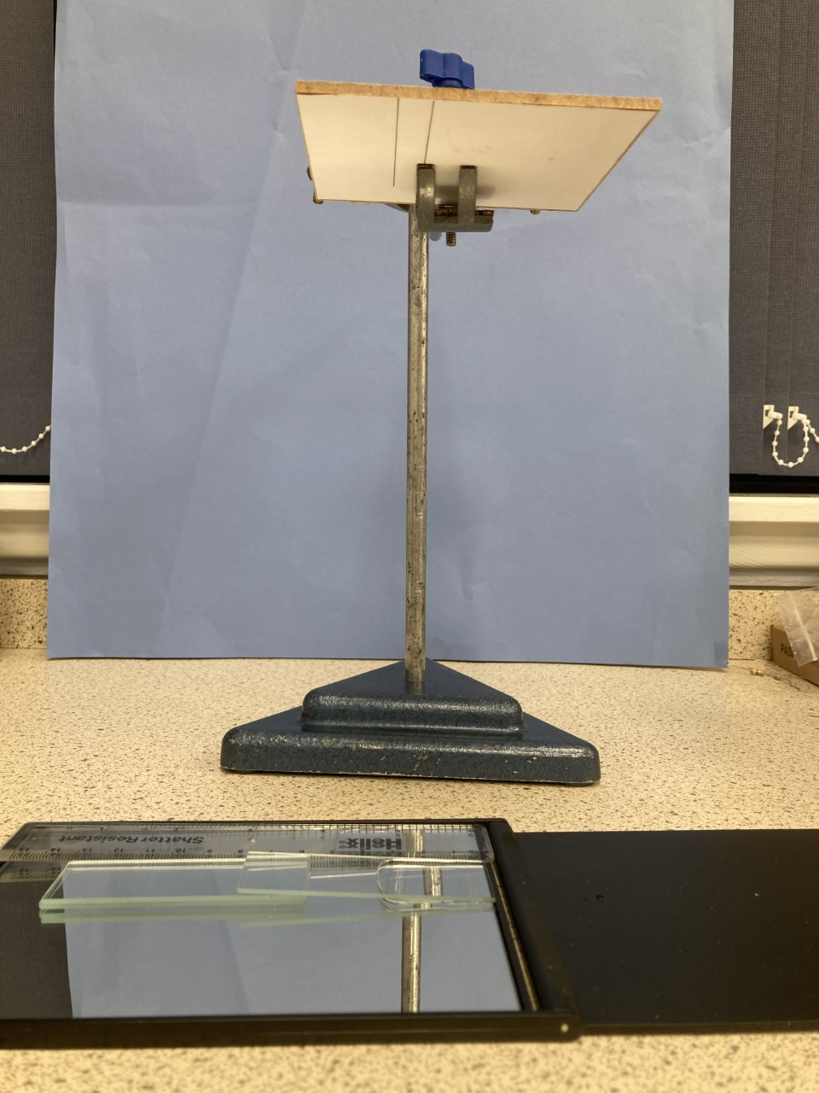

**Figure 1**

Method

On the 10cm square piece of paper draw two parallel lines 1 cm apart. Stick the paper onto one side of the 10cm square piece of cardboard. Using the clamp stand hold it parallel to the bench. Position the card so it is vertically above the plane mirror and the parallel lines are on its underside, see **Figure 1**. Check on looking down from above the mirror a reflection of the lines can be seen. Using a micrometer measure the thickness of two microscope slides 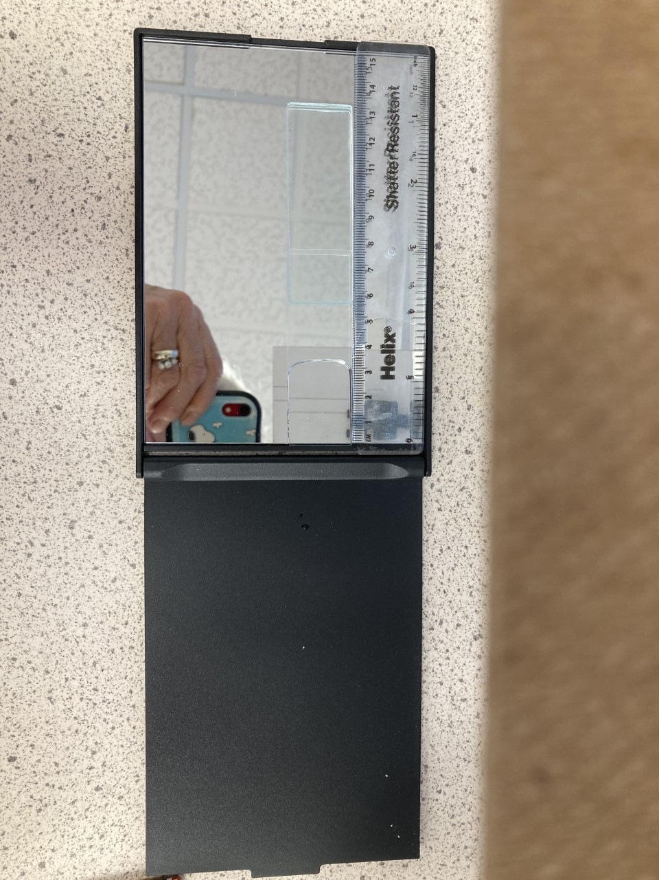placed one on top of the other and record it. Place these two microscope slides on top of each other on the plane mirror 5cm from one of its edges. Using the dropping pipette put a few drops of water onto the plane mirror between these microscope slides and the edge of the mirror. Rest the third slide so that one end is supported by the two microscope slides and the other rests on the mirror and forms a water prism with a small refracting angle, see **Figure 1**. Look down into the mirror from above the piece of card and the two reflected lines are now displaced, see **Figure 2**. By adjusting the height of the card the centre two lines can be aligned, see **Figure 3**.

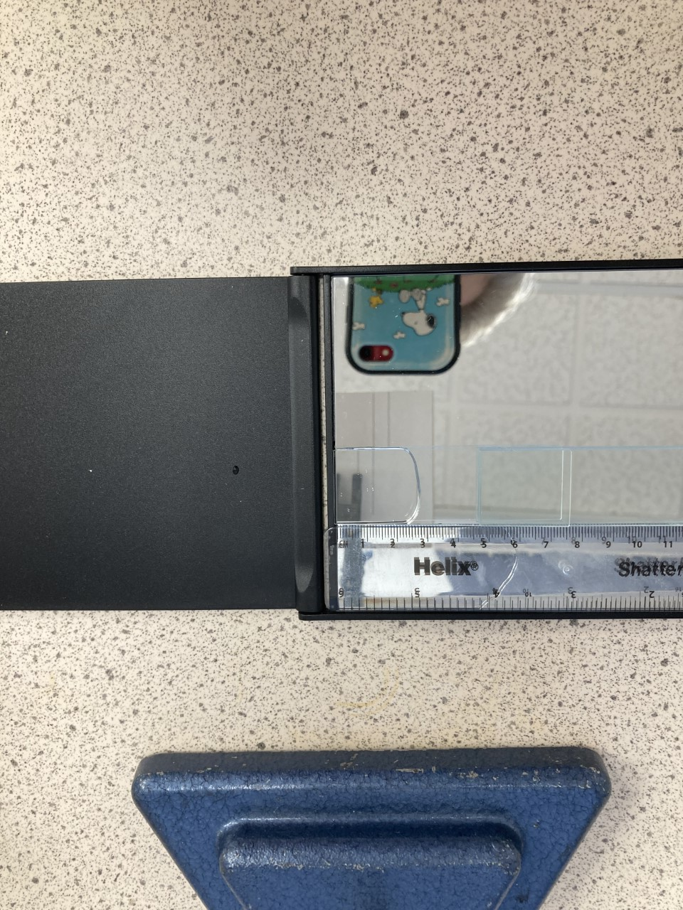

**Figure 2**

**Figure 3**

The relationship between the height (h) of the card above the plane mirror and the distance (d) between the apex of the prism and its base, the two microscope slide spacer, is given by:

h = 5d/(n-1)t,

where t is the thickness of the spacer, see **Figure 4**.

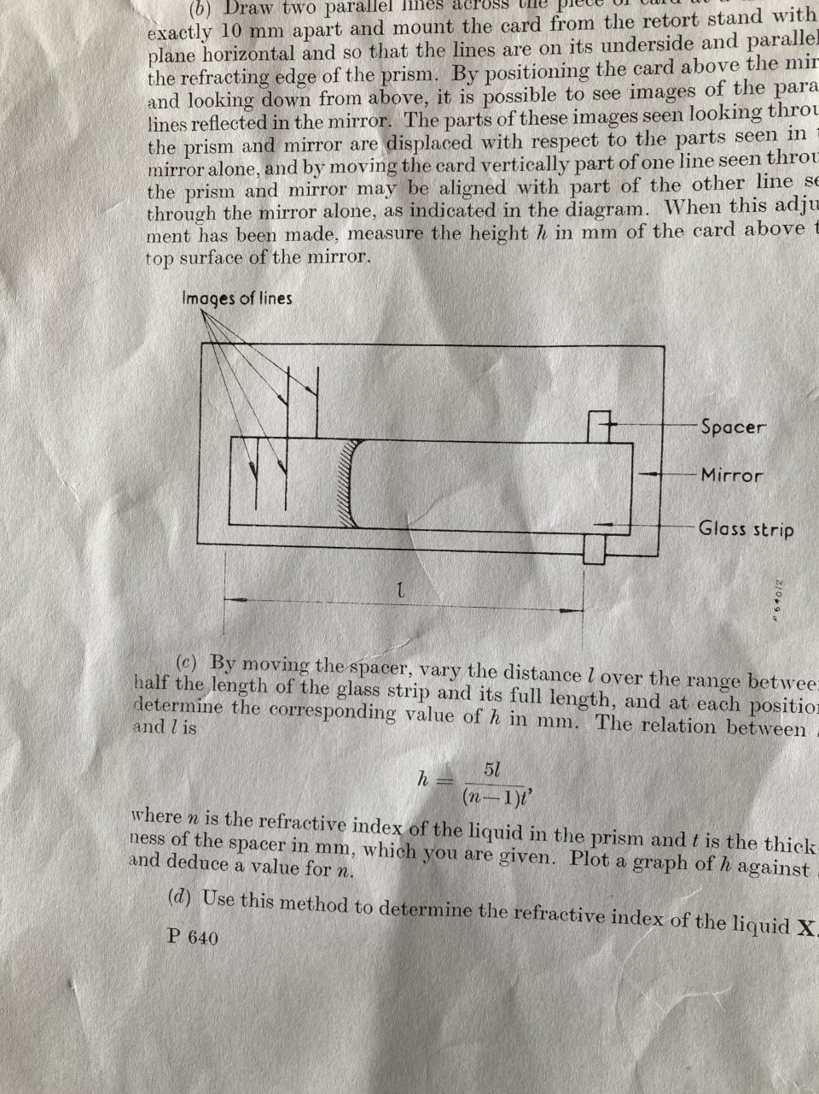

d

**Figure 4**

Change the distance (d) between the apex of the water prism and the edge of the spacer, the two glass microscope slides, and find the height (h) above the top surface of the mirror that the centre lines are aligned, record this height and distance. Repeat this for a range of values of (d). Remember this theory is only valid for prisms with a small refracting angle so d should be 30mm or greater. Plot a suitable graph to find n, the refractive index of water.

Theory

A

i4

i1

α

δ

D

i33

C

B

i2

E

The deviation produced by the prism is given by δ, the angle the incident ray makes with the emergent ray. The normal to the prism faces meet at E.

Angle BEC = (90 - α) so it follows that (i2 + i3) = α

Angle DBE = i1 vertically opposite angles

Angle DBC = Angle DBE – i2 = (i1 – i2)

Similarly angle DCB = (i3 –i4)

Looking at triangle DBC, δ = (i1 – i2) + (i4 –i3) which can be written as δ = i1 + i4 –α.

For a thin prism where i1 is very small, it follows that i2 will also be small unless n1 is very much greater than n2 which is highly improbable since refractive indices are typically lie between the limits of 1 and 2. If the refracting angle of the prism is small too, 5 degrees or less, then i3 is small since α = (i2 + i3). Finally i4 is also small.

For small angles the sine of the angle is approximately equal to the angle in radians. Using radians and applying Snell’s law gives:

n1i1 = n2i2 and n2i3 = n1i4.

The angle of deviation δ = i1 + i4 –α, can therefore be written as: =

δ = (n2i2/n1) + (n2i3/n1) – α = (n2/n1)(i2 + i3) – α.

Remembering α = (i2 + i3) the angle of deviation δ = α((n2/n1) – 1)

For this experiment n1 = 1 since it is air giving δ = α(n -1).

From the geometry the refracting angle of the water prism in radians = t/d.

After passing through the water prism the ray is reflected so the angle of deviation will be doubled. Therefor 2δ = 10mm/h, since the deviation is 10mm when the central lines are aligned.

This gives δ = 5mm/h = (t/d)(n-1) or h = (5mm)d/((n-1)t).

When processing results it is essential the units are consistent. All lengths must be measured in the same units, hence if the line separation is measured in mm all other lengths must be given in mm.