Making and testing biofuels
Activity 1
Aim: To produce ethanol using fermenting yeast
Part 1- Materials – set up as a demonstration 1 week before course:
51.5 g sucrose | 500 cm³ beaker
200 cm³ water | aluminium foil
7 g Baker’s yeast | 0.35 g sodium hydrogen carbonate
Incubator at 40 °C | Weigh boat
Spatula | Balance
Magnetic stirrer and flea | 250 cm³ beaker
2L ice cream tub container or equivalent

Part 1- Method – Setting up fermentation
- Add 51.5 g sucrose and 150 cm³ water to a 500 cm³ beaker.
- In a separate beaker, combine 7 g yeast, 0.35 g sodium hydrogen carbonate and 50 cm³ water.
- Combine the yeast suspension with the sucrose solution in the larger beaker and continue to mix.
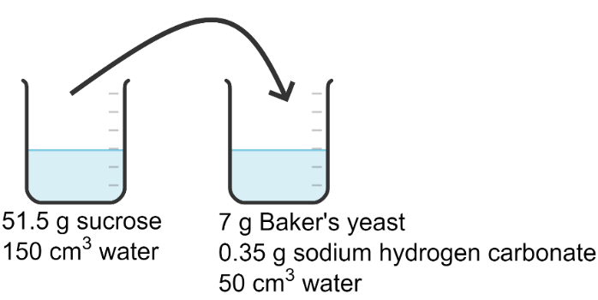
- Place an aluminium foil lid over the beaker. Place the beaker inside a suitable container to catch any spills. Place in an incubator.
- Leave the yeast to ferment at 40 °C for 7 days.

Part 2- Materials – During session, carry out distillation:
2x retort stands and clamp | Heating mantle
Condenser | 4x collecting tubes and rack
Cotton wool or bungs for collecting tubes | Fermentation reaction from Part 1
500 cm³ round-bottomed flask | thermometer
Bumping granules

Part 2 - Method – Distillation
- Transfer the fermentation reaction from Part 1 to a 500 cm³ round-bottomed flask. Secure this in the heating mantle and slowly increase the temperature.

- Gradually heat the fermentation reaction and turn the heating mantle down very low when the temperature reaches approximately 80 °C. The aim is to distil the ethanol without any water.

- As liquid is distilled around 78 °C, collect in a collecting tube. Collect about 1 cm³ and then secure the top of the tube with cotton wool, a bung or parafilm to minimise evaporation.
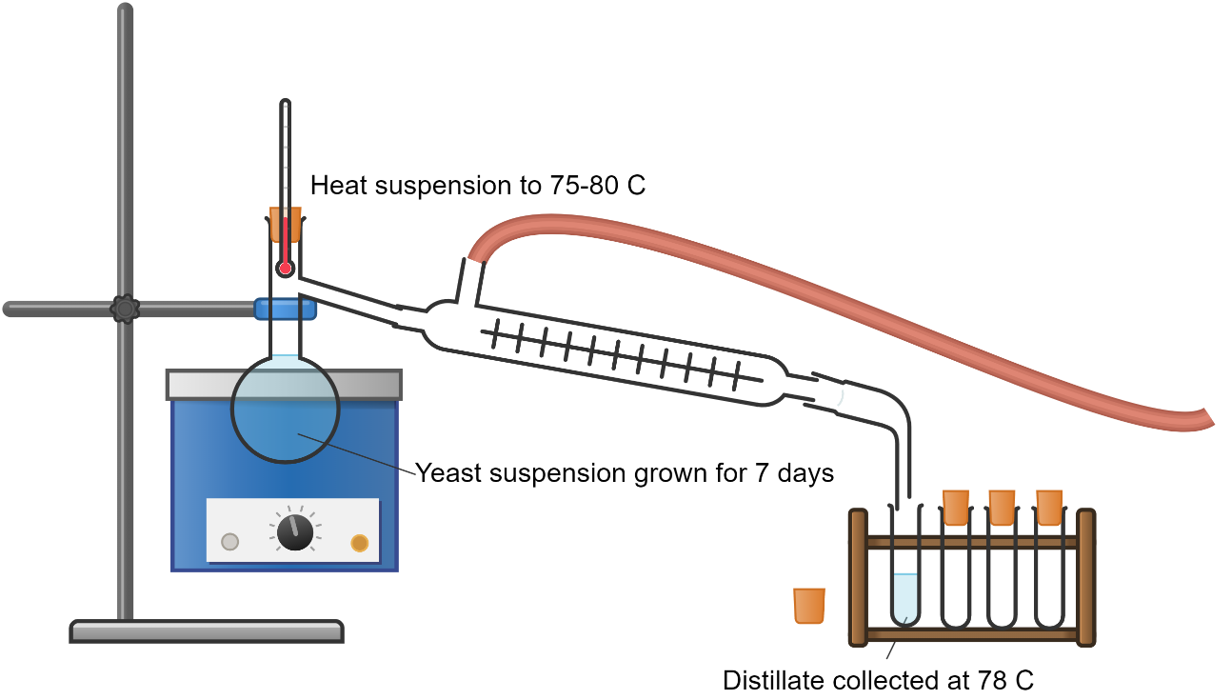
- Continue collecting distillate in a fresh collecting tube. Again, collect about 1-2 cm³, secure with a bung, and then move onto a fresh collecting tube. It is likely that water might start to evaporate from the fermentation reaction at some point, as the temperature increases, and this approach will minimise contamination of ethanol with water.
Part 3 - Materials – During session, test the distillate as a biofuel
Watch glass | Collecting tubes of distillate
Gas lighter | salt
1cm³ plastic pipette

Part 3 - Method – Testing for ethanol production
- Use the plastic pipette to transfer ~1 cm³ of distillate from collection tube 1 to a watch glass. Add a spatula of salt – this will give any flame a colour to detect more easily. Ignite the liquid.
- Repeat step 1 with the other distillate fractions.

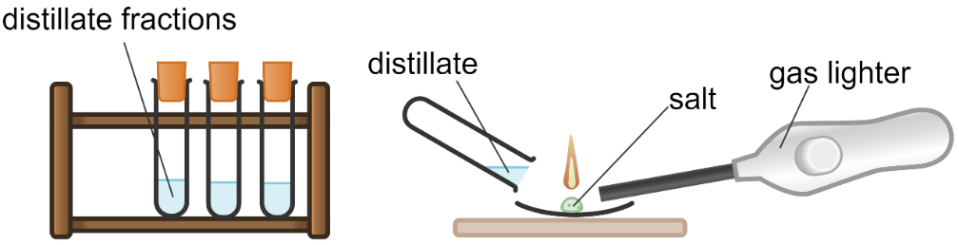
Activity 2
Aim: Make your own biodiesel from vegetable oil
Background: -
Biodiesel is a renewable, biodegradable fuel manufactured from vegetable oils, animal fats, and waste cooking oil. Biodiesel is an alternative clean-burning renewable fuel, similar to conventional diesel. It can be used as a replacement for fossil diesel fuel or mixed with petroleum diesel fuel in any proportion. Due to its biodegradable nature, it is considered environmentally friendly.
Important Features of Biodiesel:
- Biodegradable and Renewable: Biodiesel breaks down naturally and is derived from renewable sources.
- Low Toxicity: It is safer to use and has lower toxicity compared to fossil diesel fuel.
- Reduced Exhaust Emissions: Biodiesel emits fewer pollutants than regular.

You will need: -
Vegetable oil | Bungs for test tubes
Potassium methoxide (toxic and corrosive) | 100cm³ beakers
Salt solution (5%) | 10cm³ syringe
Eye protection | 3cm³ pipette
Gloves | Timer
Test tubes | Centrifuge
Test tube rack

To do:
- Measure 10 cm³ vegetable oil into a test tube.
- Add 2 cm³ potassium methoxide.
- Stopper the test tube and shake for 1 minute.
- Place in centrifuge and run for 5 minutes. (if you don’t have a centrifuge, leave overnight to settle)
- Using a pipette, remove the top layer into a second test tube.
- Add 2 cm³ of salt solution and invert 10 times. Do not shake as an emulsion can form.
- Leave to stand for 5 minutes to settle out. Transfer the top layer to a third test tube.
- You have now made biodiesel and are ready to test it.

Activity 3
Aim: - To calculate the energy produced when burning biodiesel (and other fuels).

Background: A fuel is defined as a substance that burns in oxygen to produce heat. This heat is difficult to measure directly but is straightforward to measure indirectly.

You will need: -
Biodiesel sample (or other fuel) | Tripod
Evaporating basin | Thermometer
2 decimal place balance | Cotton strip and copper wire
Copper can | 3cm³ pipette
Timer | Lighter
100cm³ measuring cylinder

To do:
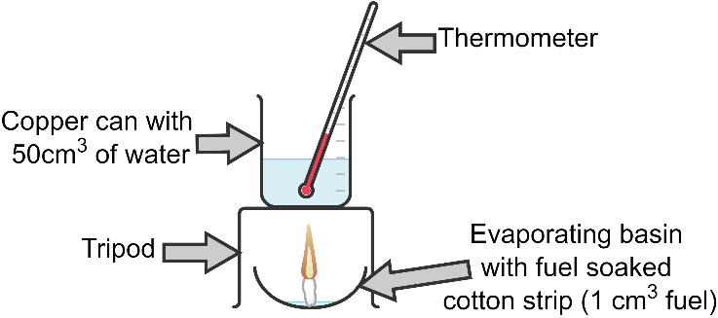

- Roll up the cotton strip and fasten it with a small piece of copper wire at the bottom. Squash it down slightly to create a foot to allow it to stand.
- Place it in the evaporating basin and soak it with 1cm³ of your biodiesel.
- Place the evaporating basin on the balance and record your starting mass (this is important).
- Measure 50cm³ of water and place it in the copper can.
- Place the evaporating basin under the tripod and the copper can on top.
- Record the starting temperature of the water.
- Light the cotton with a lighter and start the timer.
- Allow to heat for 1 minute and then blow out.
- Reweigh the evaporating basin and record the mass.
- Allow the temperature of the water to rise until it stops and record this value.
- Carry out calculation as shown below to work out the energy released.

Results and Calculations:
Fuel | Start mass of evaporating basin (g) | End mass of evaporating basin (g) | Mass of fuel burned (g) | Start temperature of water (°C) | End temperature of water (°C) | Change in temperature of water, ΔT (°C)

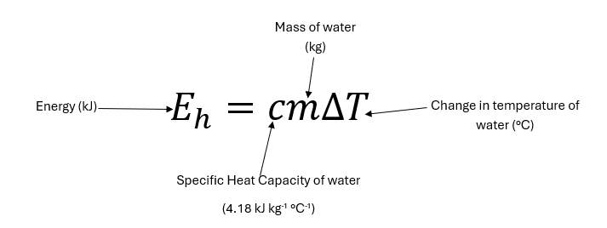
E = 4.18 x 0.05 x _______
= ________ kJ

_____ g of biofuel burned = ________ kJ
Therefore 1g biofuel burned = ________/________ = ___________ kJ g⁻¹.

