

Chemical

experiments
Testing for Esters – The ferric hydroxamate test

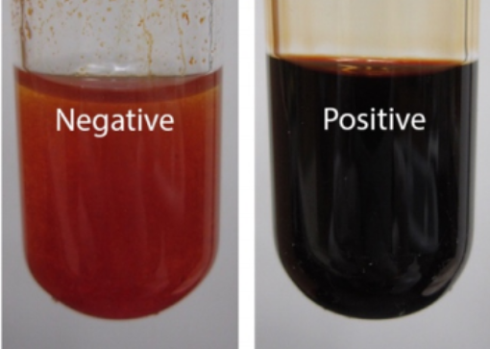
Introduction
Image from chem.libretext.org
If you have a carbonyl compound which is not an aldehyde or ketone or carboxylic acid, it could be an ester.
The most common test for an ester is simply a boiling point or melting point test but there is a relatively simple generic test: the ferric hydroxamate test.
In this test, the ester is converted to a hydroxamic acid (HOHN-C=O) which will give a colour change with Iron III (ferric) chloride.

You will need
Test tube and rack | balance
95% Ethanol/IDA* | Iron III chloride solution (5%)
Hydroxylamine hydrochloride solution (0.5 mol l⁻¹) | Hydrochloric acid (1 mol l⁻¹)
Sodium hydroxide (6 mol l⁻¹) | Pasteur pipette(s)

* Despite there being not much apparent difference, it is important not to use ‘neat’ IDA – the test won’t work.
Make up the solution by adding 5 cm³ distilled water to 95 cm³ ethanol/IDA.

Since enols can give a positive ferric chloride test, first test your compound with ferric chloride solution as follows:

- Dissolve 10 mg of solid (or 1 drop of liquid) unknown in 1 cm³ of 95% ethanol/IDA.
- Add 1 cm³ of 1 mol l⁻¹ HCl.
- Then add a 1-2 drops of 5% iron III chloride solution.
- If you obtain a colour other than yellow, the test cannot be used.

Otherwise, continue with the test as follows:

Method
- dissolve 50 mg of solid or 2 drops of liquid unknown in 1 cm³ of 0.5 mol l⁻¹ hydroxylamine hydrochloride in ethanol (IDA) and 0.2 cm³ 6 mol l⁻¹ NaOH.
- Heat to boiling in a hot water bath for 2-3 minutes, then cool and add 2 cm³ 1 mol l⁻¹ HCl.
- If the solution becomes cloudy, add 1-2 cm³ of 95% Ethanol/IDA to clarify.
- Add 1 drop of 5% Iron III chloride solution.
- If a red colour forms and then fades, add additional drops of 5% iron III chloride until the colour persists.

A deep burgundy colour is positive - due to a complex between the hydroxamic acid and the iron III ion.

