Measuring the speed of sound in air using a Helmholtz resonator
Students will be familiar with Helmholtz resonators as they are present in all stringed instruments, the resonator being the body and sound holes of the instrument. Helmholtz modelled a simple acoustical system and such systems are referred to as Helmholtz resonators because of his work. A plastic bottle is a very basic Helmholtz resonator.
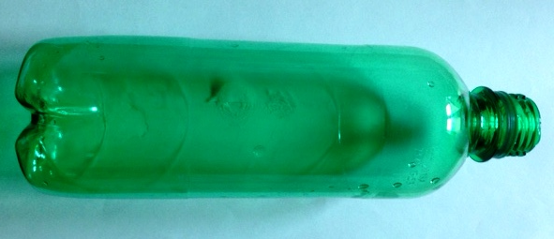
Apparatus
- 500 ml plastic bottle
- Measuring cylinder 50 ml
- Audacity software
- Water
Method
Before starting the experiment make sure when you blow gently across the top of the empty bottle you can get a good resonant tone. Practise until you can achieve this as the experiment relies on being able to blow across the top of the bottle correctly, so you can get a tone. Bottles with a 3 cm neck I found worked well for getting the range of resonant frequencies required.
Download audacity onto the device you are using for this experiment. Open audacity and start blowing across the top of the empty bottle. When a tone is sounding start recording by clicking on the red button at the top left of the screen, see figure 2.
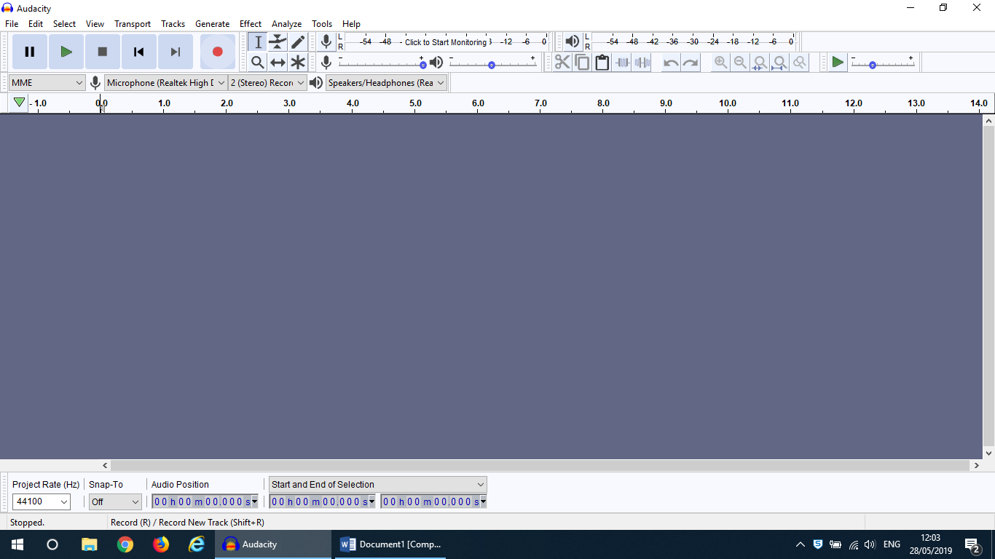
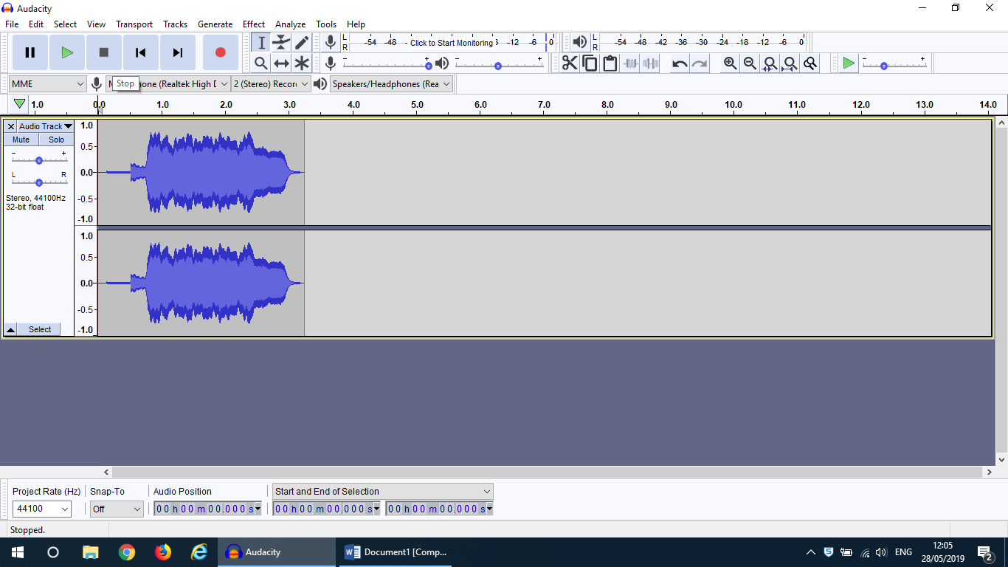

Figure 2
Record a trace for about 6 seconds then press the stop icon, the black square button to the left of the recording button, see figure 3.
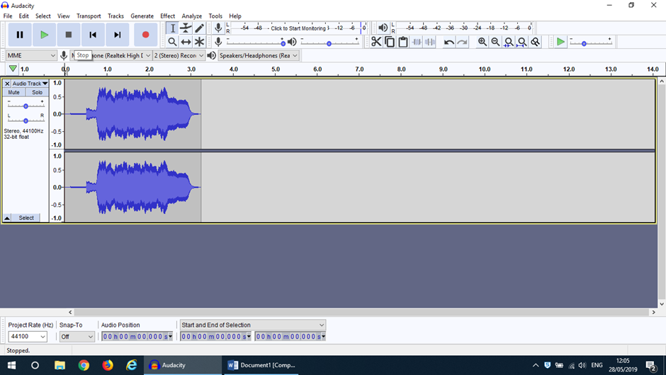
Stop button

Figure 3
Left click on the selection tool, which is the I symbol to the right of the red record button, see figure 4. Move the cursor to start of the section of recording to be analysed, then hold the left hand side of the mouse down and drag it across the recording until the section to be analysed has been covered. Release the mouse. The section to be analysed is now highlighted, see figure 5.
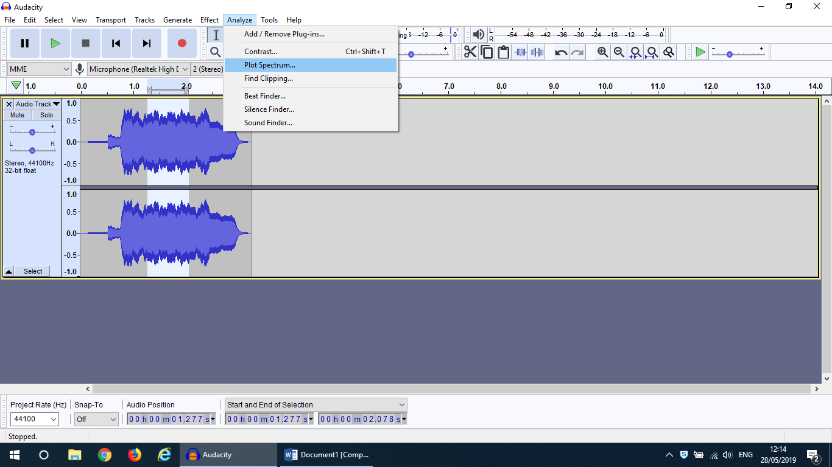
Left click on analyse which is above and to the right of the selection tool I and on the menu that comes up on the screen click on, plot spectrum. A graph comes up like the one shown in figure 6.
Figure 5

Main peak

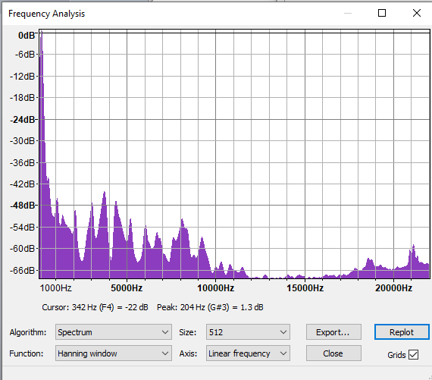
Frequency

Figure 6

The dominant frequency is found by moving the cursor over to the largest amplitude peak and then reading the peak frequency displayed below the graph, see figure 6. For this plot the dominant frequency is 204Hz.
Repeat the experiment each time adding 500ml of water, measured out accurately using the measuring cylinder, to the bottle. Each time water is added find the

resonant frequency for the resonator. Record the volume of water added to the bottle and the dominant frequency each time.
Theory
Blowing across the top of the bottle causes the air trapped in the neck of the bottle to oscillate. This mass of air undergoes simple harmonic motion.

d
d
m
m
L
L’
blow

The air in the bottle acts like a spring. The equation for the oscillation of a spring is given by:
f_{mechanical} = 1/2π√(k/m),
where k is the spring constant and m is the mass of the oscillating object. In this set up the oscillating mass is the mass of air in the neck of the bottle.
Mass of air = 2π(d/2)²Lρ_{air,}
Where d is the internal diameter of the bottle neck, L is the length of the bottle neck and ρ_{air} is the density of air.
K is an effective spring constant for the air in the bottle which can be derived using the gas laws, see The journal of the acoustical society of America 125,2627(2009);10.1121/1.4784018
Substituting into the equation gives:
f_{acoustic} = c/2π√(πd²/4)/(L’ V)
Where c is the speed of sound in air and L’ is an effective length which is used when calculating the resonant frequency although L is used to calculate the mass of air in the neck of the bottle.

Just like when doing the experiment with standing waves to measure the speed of sound in air using a column of air there is an end correction factor which is given by:
L’ = L + 0.7d_{i.}
The following is the final equation.
f_{acoustic} = c/2π√(πd²/4)/(L’ V)
This can be used to plot a straight line graph from which the speed of sound (c) can be calculated.
Useful information When using audacity, trying to measure the resonant frequency by using the trace and measuring the period I found did not have sufficient accuracy.
Listen up project: https://asa.scitation.org/doi/pdf/10.1121/1.3112687

