Kick Sampling
Aim: To investigate the effect of water velocity on invertebrate diversity

Background:
Aquatic invertebrates are small animals, lacking a backbone, that live under water often found attached to or among stones, gravel etc. Within freshwater systems, juvenile (larvae) and adult organisms can be observed, which vary throughout the year. Varieties typically include insects, crustaceans, mites, spiders, worms and leeches. Many of these organisms serve as pollution indicators, with particular organisms more or less able to thrive in oxygen-deprived areas. Their relative abundance provides information about the health of an ecosystem.

Kick-sampling is a straight-forward method to provide a sample of the organisms living in a freshwater system. After performing the kick-sample, the sample is searched in a tray and all invertebrates present are recorded and counted. The kick-sampling technique can then be used in a contrasting aquatic environment to determine the effect of a chosen independent variable. In this protocol, the Simpson’s Biodiversity Index will be used to determine both species richness (i.e. the number of different species present) and species evenness (i.e. the distribution of each species).

Materials (per pair):
Net (D-shaped) | Hand lens
Sampling tray | Stopwatch
Plastic spoon | ID guide (Invertebrates)
Antibacterial hand wipes | Orange
1 m tape measure | Paint palette

Method:
- Working in pairs, identify a section of the stream that is moving faster or slower.

- To measure water velocity:
An orange will be used to determine water flow rate. An orange is a good object to use because it has enough buoyancy to float just below the surface of the water.
  - Measure 1 m, identifying the start and end point of your distance.

  - Place the orange into the water at the start point. Use a stopwatch to time how long the orange takes to reach the finish line. If the orange gets stuck, gently nudge it to move it along or re-take the measurement.

  - Calculate velocity (distance (m) / time (s)).

- To perform kick sampling:
  - This is suitable for shallow water with a gravel/mud bottom.

  - Hold the net facing you, close to your feet, downstream of where you are standing.

  - Use one foot to kick the bottom of the stream, dislodging the substrate in the direction of the net. Invertebrates dislodged should be washed into the net. Carry out the kick sampling procedure for 60s.

- Transfer the material from the net to the sampling tray. Allow the substrate to settle in the tray and then, using the ID guides, identify the organisms present at the first site. How many different invertebrates were present (diversity) and how many organisms in total (abundance) were found?

- Repeat this process two further times.

- If time allows, move to a second site in the stream OR share data with another pair.

Adaptations to kick sampling procedure:
A 50 cm x 50 cm quadrat can be placed on the bed of the stream. Kick sampling can be performed within the area of the quadrat, ensuring that the mouth of the sample net covers the full quadrat width. By standardising kicking time and area disturbed, the data generated allows a direct count of invertebrate density. If only time is standardised, the data reveals a relative estimate of invertebrate abundance.

River Velocity: SLOW______________________
Species | Number of organisms Trial 1 | Number of organisms Trial 2 | Number of organisms Trial 3 | Mean number of organisms (n) | n-1 | n(n-1)
Mayfly nymph
Stonefly nymph
Dragonfly Larvae
Water Flea
Diving beetle
Water mite
Freshwater shrimp
Flat worm
Leech
True worm
Total

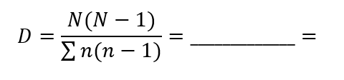

When water velocity is ________________, the Simpson’s biodiversity index score is _______________.
River Velocity: FAST_____________________
Species | Number of organisms Trial 1 | Number of organisms Trial 2 | Number of organisms Trial 3 | Mean number of organisms (n) | n-1 | n(n-1)
Mayfly nymph
Stonefly nymph
Dragonfly Larvae
Water Flea
Diving beetle
Water mite
Freshwater shrimp
Flat worm
Leech
True worm
Total

When water velocity is ________________, the Simpson’s biodiversity index score is _______________.
Processed data:
Water velocity (m/s) | Simpson’s Biodiversity Reciprocal Index
Conclusion
As water velocity increases, the biodiversity of the freshwater system _______________, as indicated by the ______________ in Simpson’s Biodiversity reciprocal index score.

Simpsons Biodiversity Index - Example
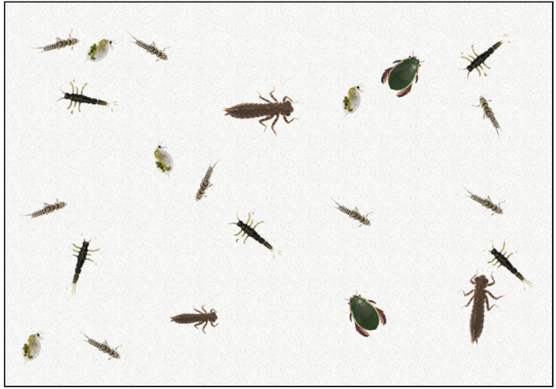
Ecosystem A

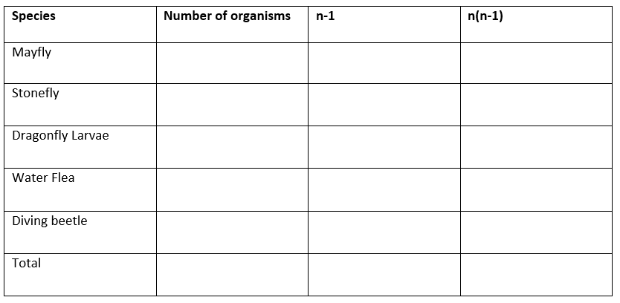
Ecosystem B
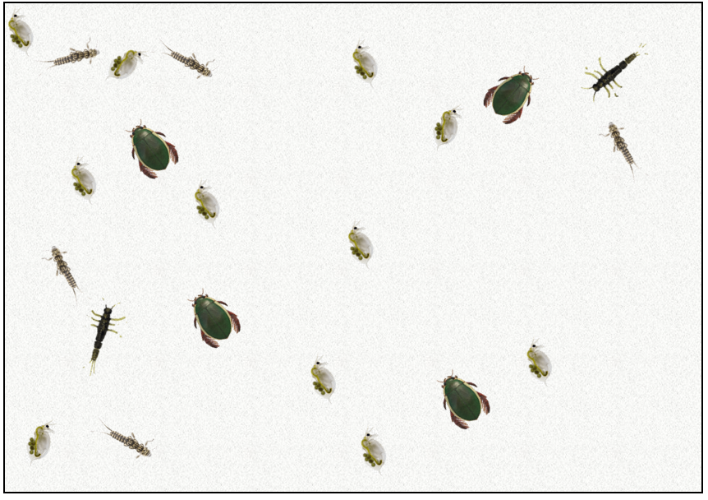

Which ecosystem has the highest level of biodiversity?

What does the Simpson’s biodiversity index show?

