

|  |
| --- |
| Chemistry Experiment |
| Synthesis of ethyl ethanoate |
| Teacher/Technician Guide |

# The Best Nail Polish Remover Pads, According to Our Editors | Makeup.comIntroduction

Ethyl ethanoate (ethyl acetate) is a common solvent with many uses: most particularly as an alternative to propanone (acetone) in nail-polish removers and as a solvent to remove caffeine from tea and coffee.

Its popularity as a solvent is due to its low toxicity and not unpleasant odour as well as the fact that it is cheap to make. The reason for the low cost is that it is synthesised from ethanol and ethanoic acid, both of which can be easily and cheaply made themselves.

The reaction is catalysed by concentrated sulphuric acid.

The reaction is slow and also reversible.

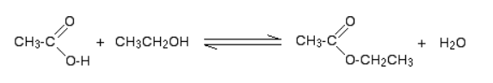

To reduce the chances of the reverse reaction happening, the ester is distilled off as soon as it is formed.

The reaction mechanism is complex (you can find it at the end of this document) but taken as a whole, this is a dehydration reaction.

A by-product of the reaction is ethoxyethane (diethyl ether).

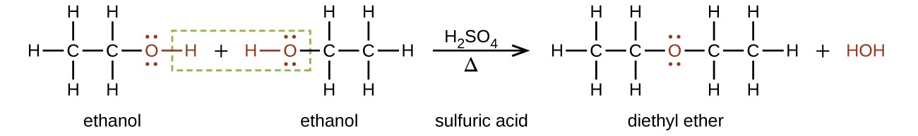

This is removed by the final distillation as it has a boiling point much lower than the ester.

As an experiment for Advanced Higher chemistry students, the synthesis highlights a range of practical skills which students need to become familiar with:

*reflux, distillation, fractional distillation, solvent extraction and drying of solvents*

The synthesis is too long to be completed in a single lesson (even a double period) but there are various points where the process can be stopped to await the next session.

## Step 1 - Reflux & first distillation

**You will need**

|  |  |
| --- | --- |
| 50 cm3 measuring cylinder* | Bottles of Ethanol and Ethanoic acid (~60 cm3) |
| 10 cm3 measuring cylinder | Small bottle of sulphuric acid |
| 3 cm3 Pasteur pipette | 250 cm3 round-bottomed flask |
| Heating mantle | Leibig condenser (& hoses) |
| Clamp and stand | Small ice bath |
| Still head & thermometer stopper | 100 cm3 conical flask |
| Anti-bump granules | Thermometer 0 - 100 |
| Keck Clips (optional) |  |

* This can be used for both the ethanol and ethanoic acid

**To do**

Wear goggles (BS EN166 3) and gloves for handling the sulphuric acid.

1. Mix 50cm3 of ethanol and 50cm3 of *glacial* ethanoic acid thoroughly in a 250cm3 round-bottomed flask.
2. **Slowly** add *(*with cooling and shaking) 10cm3 of concentrated sulphuric acid. Keep mixing until you have a homogenous mixture.

*Concentrated sulphuric acid is much denser than any of the other reagents. If it is not properly mixed, the solution may overheat and boil uncontrollably later in the reaction*

1. Ensure that the mixture is fully mixed and add a few anti-bumping granules.

*If you forget, do not just add them into the top of the hot mixture as it can boil violently and spray out of the top – wait until it is cool.*

1. Fit a condenser to the flask, arranged vertically for reflux (see diagram overleaf), place flask in the heating mantle and bring to the boil.
2. 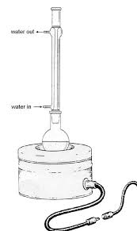Boil the mixture gently under reflux for 10 minutes.
3. Remove the flask setup from the heating mantle, allow to cool slightly for a minute or two and rearrange the apparatus so that it is set up for distillation.

*It is often best to switch the water off at this point in case the pipe pulls out of the sink and water goes everywhere – remember to turn it back on.*

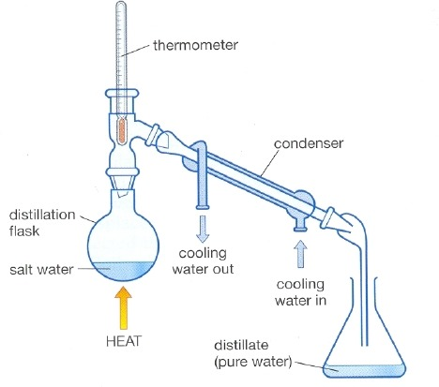

mixture

distillate

1. Replace the apparatus in the heating mantle and bring back to the boil.
2. Distil off about two-thirds of the mixture (70 – 75 cm3).
3. Switch off heating mantle and water and remove flask from the heat.

## Step 2 – Separating and drying the crude ethyl ethanoate

**You will need**

|  |  |
| --- | --- |
| 25 cm3 measuring cylinder | Bottle of 30% sodium carbonate (~ 30 cm3) |
| Clamp, stand & ring | 250 cm3 separating funnel |
| 100 cm3 conical flask | 25 cm3 of saturated calcium chloride solution |
| 100 cm3 round bottomed flask | 250 cm3 beaker (for waste) |
| Sodium sulphate (anhydrous) | spatula |

**To do**

1. Transfer the distillate to a separating funnel
2. Add about 25 cm3 of 30% sodium carbonate solution.

*The sodium carbonate will neutralise any remaining ethanoic or sulphuric acids.*

1. Stopper the funnel, invert it, and shake, opening the tap from time to time. To release any pressure build-up.
2. Place in the stand and allow the two layers to separate
3. Carefully run off the lower layer into a beaker, being careful not to leave any sodium carbonate solution behind. (this will be disposed of later).
4. Add about 25 cm3 calcium chloride to the crude ethyl ethanoate in the funnel and shake vigorously.

*The calcium chloride solution removes any remaining ethanol since it forms a complex with the alcohol.*

1. Place in the stand and allow the two layers to separate
2. Run off the lower aqueous layer, again making sure none is left behind
3. Run the ethyl ethanoate into a 100 cm3 conical flask,
4. Add a spatula or two of anhydrous sodium sulphate and shake occasionally until the liquid is clear (it may not be perfectly clear but it will be very close).

## Step 3 – Fractional distillation of pure(ish) ethyl ethanoate

**You will need**

|  |  |
| --- | --- |
| Heating mantle | Leibig condenser (& hoses) |
| Clamp and stand | Keck Clips (optional) |
| Still head & thermometer stopper | Thermometer 0 - 100°C |
| 100 cm3 conical flask | 100 cm3 beaker |

**To do**

1. Decant the liquid into a clean, dry 100 cm3 round-bottom flask.
2. Add some anti-bumping granules,
3. Arrange the apparatus for distillation including a 0-100oC thermometer in the apparatus. (This may well still be set up from earlier). Place the beaker to collect the distillate.
4. Start heating, The ether that is always formed in this reaction will distil off at 35-40oC, and may be discarded.
5. Continue to heat, allowing the distillate to continue to drop into the beaker.
6. When the thermometer reaches 74°C, switch to the conical flask.
7. Collect the fraction that boils between 74°C and 79°C.
8. Once the thermometer reaches 79°C, switch off the heat, remove the flask and replace with the beaker again to collect any drips.

## The reaction mechanism

The reaction is complex and beyond the requirements of many students but we are including it here for the sake of completion.

(Details taken from Chemguide)

### Step 1

In the first step, the ethanoic acid takes a proton (a hydrogen ion) from the concentrated sulphuric acid. The proton becomes attached to one of the lone pairs on the oxygen which is double-bonded to the carbon.

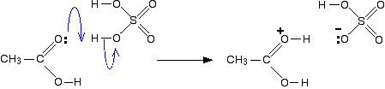

The transfer of the proton to the oxygen gives it a positive charge, but it is actually misleading to draw the structure in this way (although nearly everybody does!).

The positive charge is delocalised over the whole of the right-hand end of the ion, with a fair amount of positiveness on the carbon atom. In other words, you can think of an electron pair shifting to give this structure:

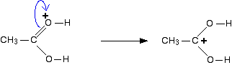

You could also imagine another electron pair shift producing a third structure:

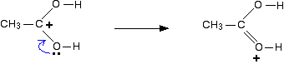

So which of these is the correct structure of the ion formed? None of them! The truth lies somewhere in between all of them. One way of writing the delocalised structure of the ion is like this:

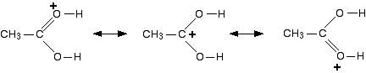

The double headed arrows are telling you that each of the individual structures makes a contribution to the real structure of the ion. They **don't** mean that the bonds are flipping back and forth between one structure and another. The various structures are known as ***resonance structures*** or ***canonical forms***.

There will be some degree of positive charge on both of the oxygen atoms, and also on the carbon atom. Each of the bonds between the carbon and the two oxygens will be the same - somewhere between a single bond and a double bond.

For the purposes of the rest of this discussion, we are going to use the structure where the positive charge is on the carbon atom.

### Step 2

The positive charge on the carbon atom is attacked by one of the lone pairs on the oxygen of the ethanol molecule.

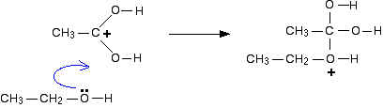

### Step 3

What happens next is that a proton (a hydrogen ion) gets transferred from the bottom oxygen atom to one of the others. It gets picked off by one of the other substances in the mixture (for example, by attaching to a lone pair on an unreacted ethanol molecule), and then dumped back onto one of the oxygens more or less at random.

The net effect is:

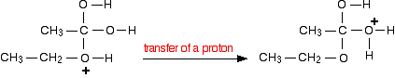

### Step 4

Now a molecule of water is lost from the ion.

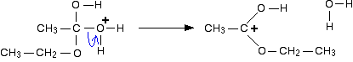

The product ion has been drawn in a shape to reflect the product which we are finally getting quite close to!

The structure for the latest ion is just like the one we discusssed at length back in step 1. The positive charge is actually delocalised all over that end of the ion, and there will also be contributions from structures where the charge is on the either of the oxygens:

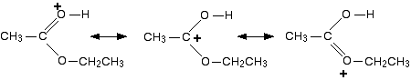

It is easier to follow what is happening if we keep going with the structure with the charge on the carbon.

### Step 5

The hydrogen is removed from the oxygen by reaction with the hydrogensulphate ion which was formed way back in the first step.

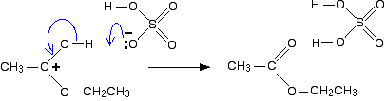

And there we are! The ester has been formed, and the sulphuric acid catalyst has been regenerated.

# Technician Guide

**Each group will need**

|  |  |
| --- | --- |
| **First Distillation** | |
| 50 cm3 measuring cylinder (This can be used for both the ethanol and ethanoic acid) | Bottles of Ethanol and Ethanoic acid (~60 cm3) |
| 10 cm3 measuring cylinder | Small bottle of sulphuric acid |
| 3 cm3 Pasteur pipette | 250 cm3 round-bottomed flask |
| Heating mantle | Leibig condenser (& hoses) |
| Clamp and stand | Small ice bath |
| Still head & thermometer stopper | 100 cm3 conical flask |
| Anti-bump granules | Thermometer 0 - 100 |
| Keck Clips (optional) |  |
| **Separation & Drying** | |
| 25 cm3 measuring cylinder | Bottle of 30% sodium carbonate (~ 30 cm3) |
| Clamp, stand & ring | 250 cm3 separating funnel |
| 100 cm3 conical flask | 25 cm3 of saturated calcium chloride solution |
| 100 cm3 round bottomed flask | 250 cm3 beaker (for waste) |
| Sodium sulphate (anhydrous) | spatula |
| **Final fractional distillation** | |
| Heating mantle | Leibig condenser (& hoses) |
| Clamp and stand | Keck Clips (optional) |
| Still head & thermometer stopper | Thermometer 0 - 100°C |
| 100 cm3 conical flask | 100 cm3 beaker |

# Method

Wear goggles (BS EN166 3) and gloves for handling the sulphuric acid.

1. Mix 50cm3 of ethanol and 50cm3 of glacial ethanoic acid thoroughly in a 250cm3 round-bottomed flask.
2. **Slowly** add *(*with cooling and shaking) 10cm3 of concentrated sulphuric acid. Keep mixing until you have a homogenous mixture.

*Concentrated sulphuric acid is much denser than any of the other reagents. If it is not properly mixed, the solution may overheat and boil uncontrollably later in the reaction*

1. Ensure that the mixture is fully mixed and add a few anti-bumping granules.

*If you forget, do not just add them into the top of the hot mixture as it can boil violently and spray out of the top – wait until it is cool.*

1. Fit a condenser to the flask, arranged vertically for reflux (see diagram overleaf), place flask in the heating mantle and bring to the boil.
2. Boil the mixture gently under reflux for 10 minutes.
3. Remove the flask setup from the heating mantle, allow to cool slightly for a minute or two and rearrange the apparatus so that it is set up for distillation.

*It is often best to switch the water off at this point in case the pipe pulls out of the sink and water goes everywhere – remember to turn it back on.*



mixture

distillate

1. Replace the apparatus in the heating mantle and bring back to the boil.
2. Distil off about two-thirds of the mixture (70 – 75 cm3).
3. Switch off heating mantle and water and remove flask from the heat.

## Step 2 – Separating and drying the crude ethyl ethanoate

1. Transfer the distillate to a separating funnel
2. Add about 25 cm3 of 30% sodium carbonate solution.
3. The sodium carbonate will neutralise any remaining ethanoic or sulphuric acids.
4. Stopper the funnel, invert it, and shake, opening the tap from time to time. To release any pressure build-up.
5. Place in the stand and allow the two layers to separate
6. Carefully run off the lower layer into a beaker, being careful not to leave any sodium carbonate solution behind. (this will be disposed of later).
7. Add about 25 cm3 calcium chloride to the crude ethyl ethanoate in the funnel and shake vigorously.

*The calcium chloride solution removes any remaining ethanol since it forms a complex with the alcohol.*

1. Place in the stand and allow the two layers to separate
2. Run off the lower aqueous layer, again making sure none is left behind
3. Run the ethyl ethanoate into a 100 cm3 conical flask,
4. Add a spatula or two of anhydrous sodium sulphate and shake occasionally until the liquid is clear (it may not be perfectly clear but it will be very close).

## Step 3 – Fractional distillation of pure(ish) ethyl ethanoate

1. Decant the liquid into a clean, dry 100 cm3 round-bottom flask.
2. Add some anti-bumping granules,
3. Arrange the apparatus for distillation including a 0-100°C thermometer in the apparatus. (This may well still be set up from earlier). Place the beaker to collect the distillate.
4. Start heating, The ether that is always formed in this reaction will distil off at 35-40°C and may be discarded.
5. Continue to heat, allowing the distillate to continue to drop into the beaker.
6. When the thermometer reaches 74°C, switch to the conical flask.
7. Collect the fraction that boils between 74°C and 79°C.
8. Once the thermometer reaches 79°C, switch off the heat, remove the flask and replace with the beaker again to collect any drips.