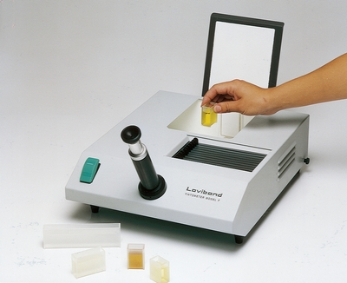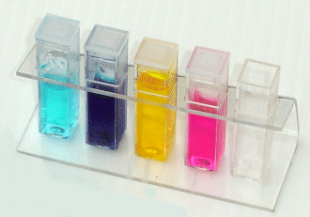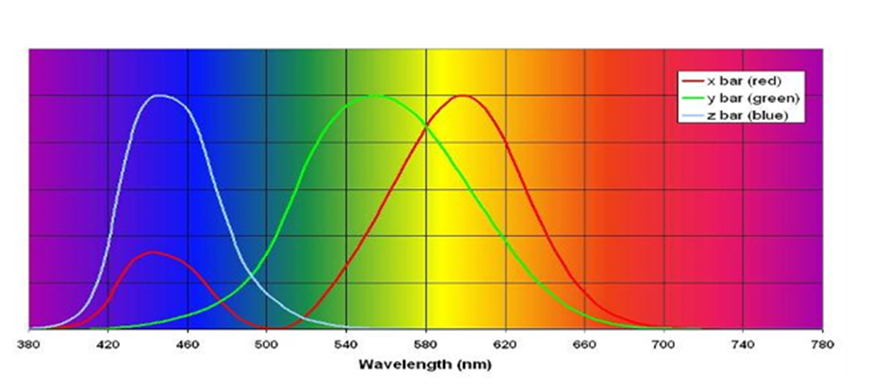
What is Colorimetry?

Colorimetry is simply the measurement of colour.
While you can see with your eyes if water is cloudy or clear, or if it is coloured, it is not possible to get an accurate measurement of just how intense a colour is or how cloudy a solution may be.
That said, given a suitable range of colours to compare with, the human eye is very good at matching shades. It is possible to determine the concentration of a solution quite accurately, given enough intermediate colours to compare.

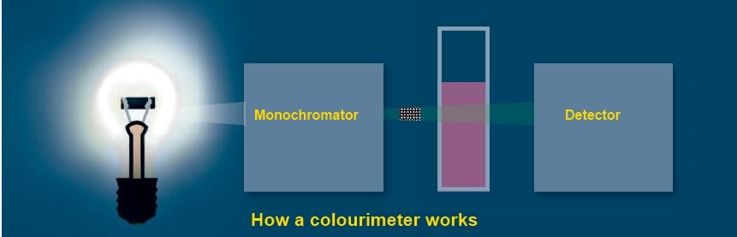A colorimeter is a device that passes light of a particular “wavelength” through a sample. Using a detector, the colorimeter can measure how much of the light has been absorbed by the sample. The amount of light absorbed by the sample is related to the concentration of the chemical of interest.
This way it is possible to get numerical values for the amount of light and given such data, there is much more that can be done.

It is possible to follow the progress of many reactions by using Colorimetry
- If a coloured compound is becoming decoloured.
- If a colourless solution is developing colour
- If a suspension is forming in a solution
- In the case where none of the above are true, it is often possible to work at one remove by reacting samples of the reaction mixture with a chemical that will give a coloured solution.

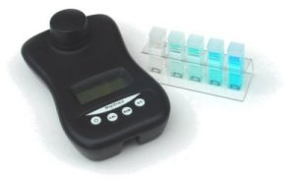Commercial Colorimeters
There are many colorimeters on the market, ranging from less than £100 to over £3,000. The simple ones we use at SSERC are made by Mystrica.

Why bother making one?
1. Cost
Even with a cheap model, a class set is the best part of £1,000. If it is possible to make a working colorimeter for a few pounds then it means that this important technique can be used more often.

2. Access
Making a colorimeter for a few pounds means that it is possible for each pupil to use one and thus everyone gets to use and understand the technology.

3. Understanding
If you can make something, you are likely to have a clearer understanding of how it works.
Making a colorimeter

You will need
Jablite insulation board (grey) either 50mm thick or a double layer of the 25mm) | Cork borer (no 7 or 8 depending on the diameter of the LDR)
1 x rubber bung | 1 x LDR
1 x white 5mm LED | 1 x 180 ohm resistor
1 short piece of insulated wire | 1 x multimeter
1 x power supply (about 4.5v)

- Cut a piece of the board to approximately 5cm x 5cm (a hot knife is the most effective method for this as it provided a firm, non crumbly edge.
- Select a cork borer that is suitable for your LDR.
- 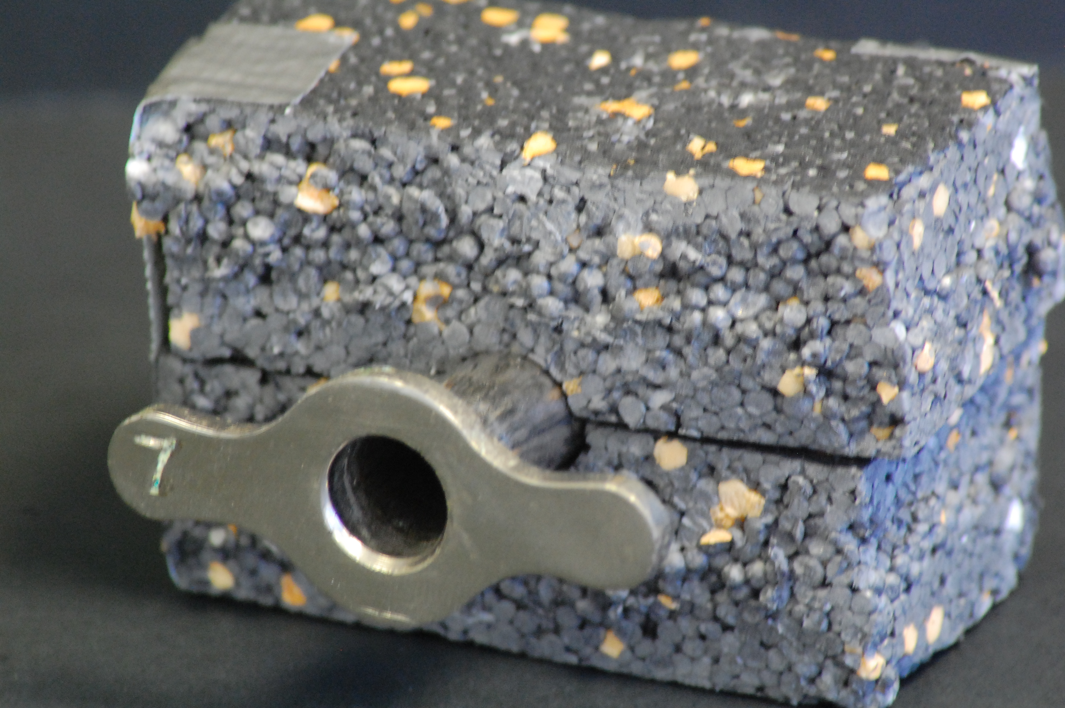Select a rubber bung that will fit the hole made by the cork borer.
- Cut the length of the bung in half, with a knife or scalpel, and keep the narrower end.
- 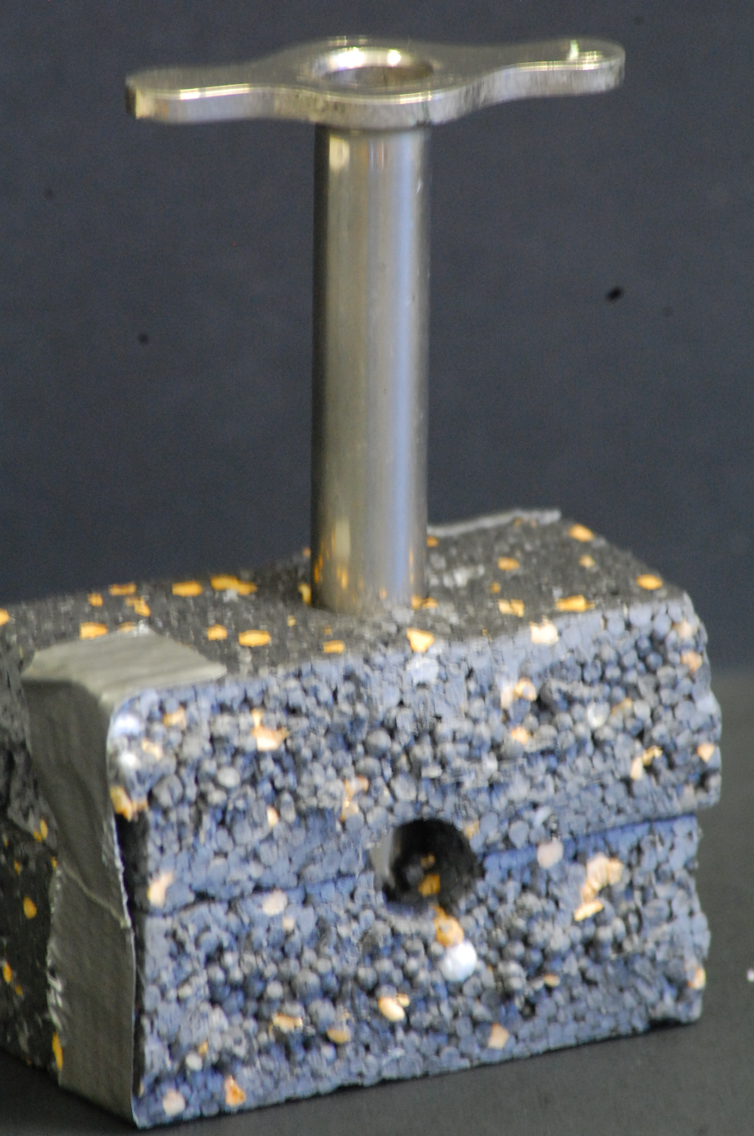Use the cork-borer to make a hole horizontally completely through the block. Take care to keep it as horizontal as possible.

- Use the borer again to make a hole vertically down from the top, taking care to make sure it crosses the line of your first hole. Don’t take this hole all the way through to the bottom.

- Check the size with a cuvette – you may need to press on the sides of the hole with a spatula. The idea is that it is a snug fit and the cuvette does not rotate.
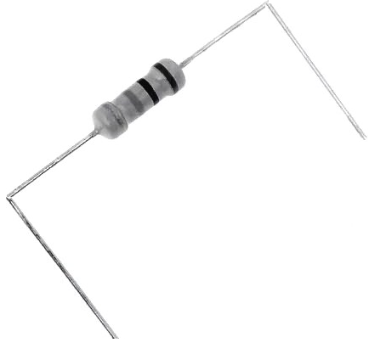
- Cover the whole block with one or two layers of aluminium foil (to lightproof it). Pierce where the holes are with a screwdriver or pencil and push the foil in.
- Insert the LED into the hole in the bung.
- 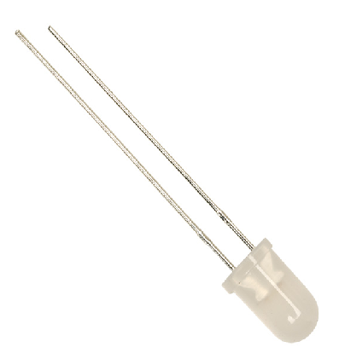Bend the arms of the resistor 90 degrees.

- Take the insulated wire and use it to connect the positive arm of the LED (the longer one) to one arm of the resistor.

- 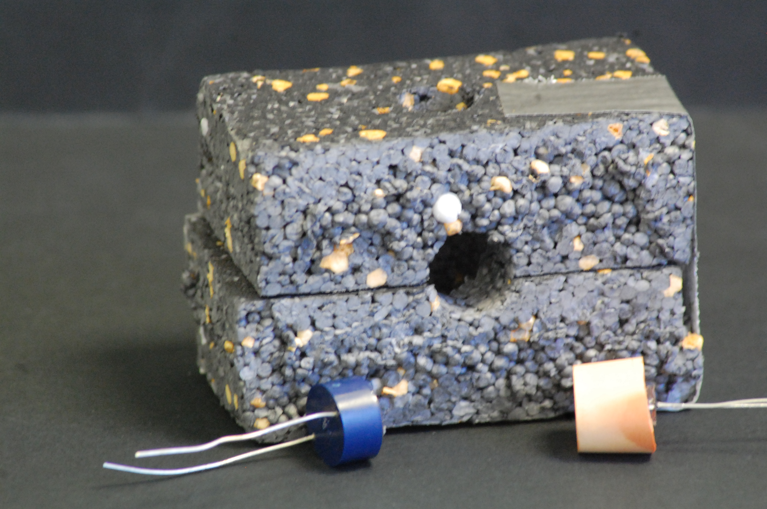Gently push the bung into one of the holes on the side of the block.
- Push the arms of the resistor into the polystyrene block.
- Connect the + terminal of the power supply to the resistor and the – to the LED and switch on briefly to make sure it lights up.

- Gently push the LDR into the hole opposite the LED.
- Connect the arms of the LDR to the Multimeter and select resistance – pick the range that gives you a good value. (20KΩ usually on the ones we are using here.

To Use
Put your sample in a cuvette.
Place it in the hole in the top.
Take a lid from a drinks bottle and use that as a cap over the cuvette to prevent stray light entering.
Switch on the LED and the multimeter
Take the reading on the multimeter.

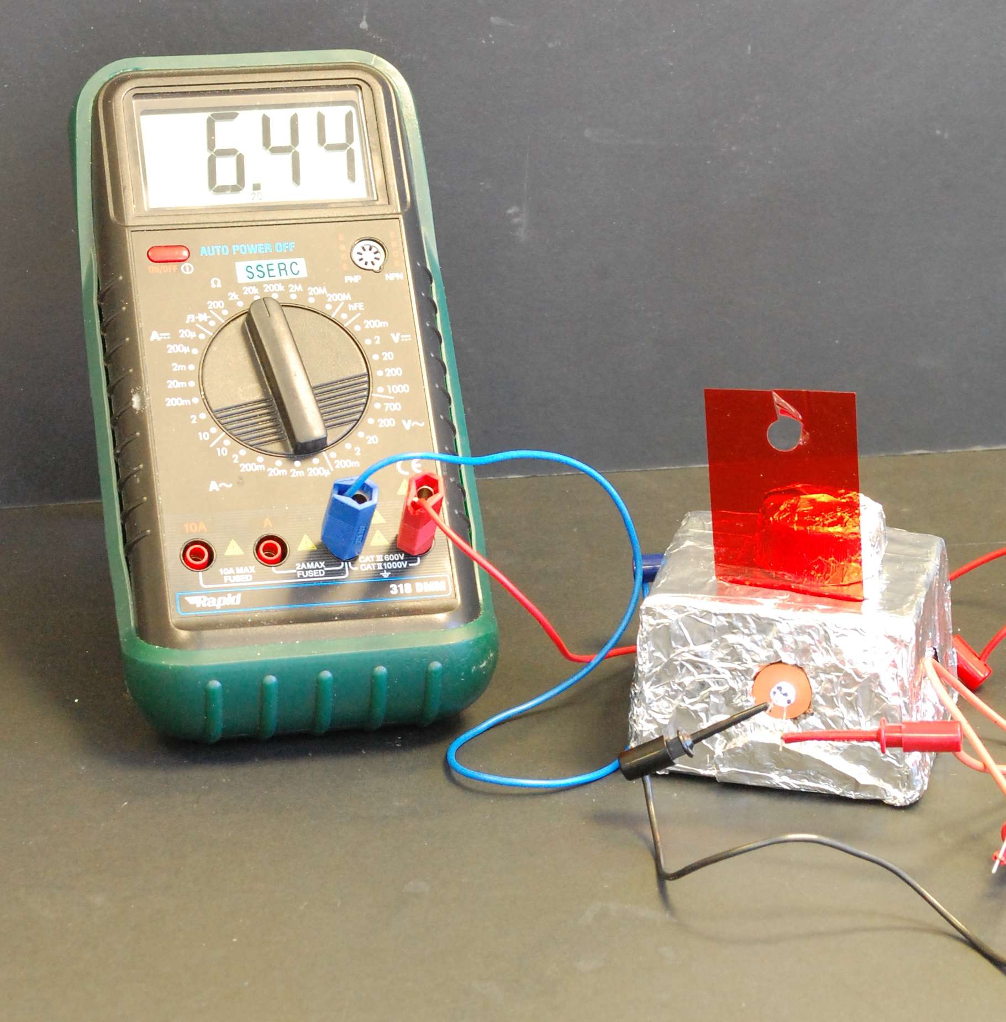
Using the colorimeter

The detector in your colorimeter is a Light Dependent Resistor (LDR). When a light shines on it, the resistance is reduced. You are using a multimeter to measure the resistance of the LDR.
Commercial multimeters give you a choice of measuring either transmittance or absorbance.
Transmittance is a measure of how much light is passes through; the highest value is when a blank cuvette is used.
Absorbance is a measurement of how much light is absorbed and in this case the blank cuvette will give a low reading.
In this colorimeter, the more light gets through (the more transparent the solution) the lower the reading. Thus it is measuring absorption rather than transmittance.

Experiments
You can use this simple device in much the same way as a ‘proper’ colorimeter for instance:
- Plotting a standard curve and using it to Work out concentrations.
- Following the course of a reaction to determine its rate

Consistency
This colorimeter is not quite as consistent as commercial one but, considering the difference in price, that is perhaps to be expected. Nonetheless, quite accurate results can be obtained with a small amount of care.
- Be careful in the construction to make sure the LED and LDR are aligned.
- It is best to make sure that a single experiment/investigation is only carried out on one device as they may give slightly different results.
- Similarly, as the brightness of the LED obviously varies with the input voltage. You will need to make sure the same voltage is being used each time the colorimeter is used. (If there is an ongoing investigation, it might be an idea to put a voltmeter into the circuit with the light)
- So these devices are probably not suitable for an Advanced Higher project but they do give an easy and cheap entry in to the very important topic of colorimetry.

Interpreting the data

In most cases, the figures for resistance can simply be used as they are.
For instance, when determining concentration against a reference graph, a simple plot of resistance against concentration will be quite usable and enable you to read the resistance of an unknown off the scale.
The graph will often look neater if it starts from zero – in which case simply take the blank, calibration reading (which you should do anyway) and subtract this from each of the other readings – excel or any other spreadsheet makes this a very easy task.

There are times when you might want to try to get more accurate data, in this case you will need to convert your resistance reading into the actual absorbance.
From the Beer-Lambert law, it is possible to work out that

A = log₁₀ I₀
I
Where I₀ is the intensity of light passing through the blank and I is the intensity of light passing through the sample
Once again, excel can come to the rescue and make the calculation quite straightforward.

Once you have this value, you can use the Beer-Lambert law to work out other information you may need.

A = ε l c
Where ε = the molar absorption coefficient of the substance (at that wavelength)
l = the length of the path through the solution (1cm in a standard cuvette) and
c = the concentration of the solution

The objective is to determine how much copper is in a sample of copper ore.
The extraction has been done and you now have a sample of copper sulphate solution.
You also have 4 samples of copper sulphate of known concentration.

You will need
5 x cuvettes | 1 x 3cm³ pasteur pipette
5 x vials of copper sulphate solutions | Distilled water

To Do
- Use a 3cm³ pasteur pipette to put 3cm³ of your first sample in a cuvette and use your colorimeter to take a reading of the resistance.
- Record your answer in the table below.
- Repeat with the other 3 samples of known concentration. (rinse the pipette out between each sample)
- Plot your readings on the graph overleaf.
- Now take the reading from the unknown.
- Use your graph to determine the concentration of copper in this sample.

Sample No | Reading
1 (0.5M)
2 (0.3M)
3 (0.1M)
4 (0.05M)
X (? M)

Resistance values of copper sulphate solutions.

0.1 0.2 0.3 0.4 0.5
Concentration (M)
sodium thiosulphate / hydrochloric acid reaction

In the presence of hydrochloric acid, sodium thiosulphate will decompose to release elemental sulphur. This sulphur remains in solution as a suspension and thus the liquid goes cloudy, reducing the transmission of light.
Na₂S₂O₃ + 2HCl → SO₂ + S + H₂O + 2NaCl
In this experiment you are going to examine the effect of HCl concentration on the rate of the reaction.
You will need
4 x cuvettes | 2 x 3cm³ pasteur pipettes
0.1M sodium thiosulphate solution | 1 x 1cm³ pasteur pipette
Distilled water | 1M hydrochloric acid

To Do
- Use a 3cm³ pasteur pipette to put 1.5cm³ of hydrochloric acid into a cuvette.
- Add 1.5 cm³ of sodium thiosulphate and immediately put your cuvette in your colorimeter, take the reading and start the timer.
- Take readings every 15s until there is no further significant change.
Cuvette No. | Vol of HCl (cm³) | Vol of H2O (cm³)
2 | 1.0 | 0.5
3 | 0.75 | 0.75
4 | .05 | 1.0
- Remove the cuvette and repeat the reaction, using the following dilutions of hydrochloric acid.

- Plot your figures on the graph overleaf.

R e stance
Time (s)

