Session 10: Amylase
Aim: To investigate the effect of [IV] on amylase activity.
Reference: Chan, K., Ho, D. and Lau, D. (2024), Using amylase beads to investigate factors affecting enzyme activity, The American Biology Teacher, 86(3), 153-160. Click here for link.

Background
Amylase, which hydrolyses starch to maltose, is often used as an example to show the effects of factors affecting enzyme activity. These protocols can require lots of hands-on manipulations and time, e.g. setting up multiple test tubes and measuring large volumes of solution. In this protocol, you will use immobilised amylase beads to study the action of amylase on starch and to investigate the effects of temperature, pH, and substrate concentration. The original paper (Chan, K., 2024) describes the use of Glucobay as a competitive and reversible inhibitor of amylase. This medication is prescribed to control Type 2 diabetes. This is readily available to purchase in China, but not in the UK. To quantify results, learners can use an RGB detector app on their smartphone.

Part 1: Immobilisation of amylase
Materials required (per pair):
5 cm³ 1% α-amylase (bacterial) | 5 cm³ 2% sodium alginate
Food colouring (optional) | 60 cm³ 2% calcium chloride
100 cm³ beaker | Retort stand
10 cm³ syringe (without plunger) | Tea strainer
Distilled water in wash bottle | Paper towels

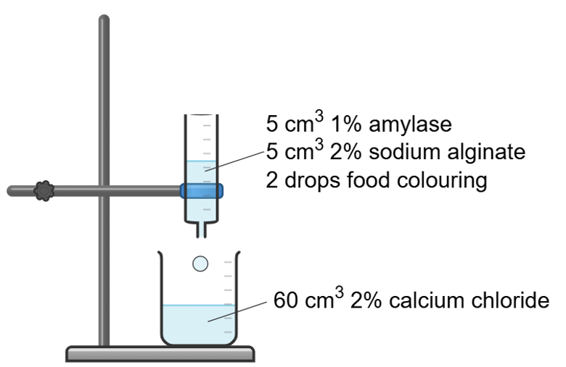
Method
  - Add the amylase solution into the sodium alginate and mix thoroughly. A few drops of food colouring can be added at this point if coloured beads are desired.Position the barrel of the 10 cm³ syringe into the retort stand, above a beaker of calcium chloride.

  - Pour the amylase/alginate mixture into the syringe barrel.

  - Allow the mixture to drop into the calcium chloride. Leave the beads to settle for a few minutes. Pour the beads and calcium chloride mixture through the tea strainer and rinse the beads with distilled water. The beads can be stored in distilled water until required.

Part 2: Action of amylase beads on starch – for information only
Materials required (per pair):
Amylase immobilised beads | 0.25% starch
forceps | dimple tile
1 cm³ plastic pipette | Stop watch
0.005 M iodine | RGB detector app
2L tub (mini water bath)

Method
  - Transfer 10 enzyme beads into 4 wells of the petri dish
  - Add 0.5 cm³ 0.25% starch into each well. Start the stop watch.
  - At 0, 5, 10 and 15 minutes, add 2 drops of 0.05 M iodine to the well.
  - Record the colour of the solution. Extract the supernatant, using a clean 1 cm³ plastic pipette, and transfer to a clean well in the dimple tile. Use the RGB detector to quantify the colour in each reaction.

Results
Incubation time (min) | Colour of iodine
 | Colour | R (%) | G (%) | B (%)
0
5
10
15

Alternative
This protocol can also be done without immobilising amylase. In this case, use 0.25 cm³ 1% amylase, 0.25 cm³ 0.25% starch and 2 drops of iodine. However, this does dilute the enzyme and we find it does work slightly better with the immobilised beads. The beads, however, are not reusable due to the effect of iodine.

All pairs will carry out 2 assays from the IV options below:
- Temperature
- pH
- Substrate concentration
Materials required (per pair):
80 x amylase immobilised beads | 5 cm³ 0.25% starch
forceps | Stopwatch
1 cm³ plastic pipette | 0.005 M iodine
RGB detector app for smartphone | Dimple tile
2L container of water at ~ 40 ºC (to act as a water bath) | 2x white tiles
Retort stand | Lamp
4x microcuvette | Distilled water wash-bottle

Materials required (per bench):
16x test tubes | 2x Thermotube blocks  (40 ºC & 80 ºC)
2x test tube rack | Beaker of iced water
1 cm³ pH buffers (pH 2, 4, 7 & 10) | 1 cm³ 0.1%, 0.2%, 0.4%, 0.6% starch

Part 3: Effect of temperature on amylase activity
Materials required:
40x Amylase immobilised beads | 4 cm³ 0.25% starch
forceps | 8x test tubes
1 cm³ plastic pipette | Stop watch
0.005 M iodine | Thermotube block (40 ºC & 80 ºC)
Beaker of iced water | RGB detector app for smartphone
2x white tiles | Retort stand
4x microcuvette | Water wash bottle

Method
  - Transfer 10 amylase beads into 4 test tubes and position in the following locations for 5 minutes:
    - Test tube 1 – beaker of iced water
    - Test tube 2 – room temperature
    - Test tube 3 – water bath at 40 ºC
    - Test tube 4 – water bath at 80 ºC

- Transfer 1 cm³ 0.25% starch into 4 test tubes. Place the test tubes in the same locations as step 1. Leave for 5 minutes.
- Pour the treated starch into the appropriate test tube of treated amylase. Incubate mixtures for 10 minutes.
- Add 2 drops of iodine to each test tube. Transfer each supernatant to a clean microcuvette. Position the cuvette in front of a white tile and photograph the sample to quantify the change in colour.
Results
Temperature (ºC) | Colour of iodine
 | Colour | R(%) | G(%) | B(%)
0
20
40
80

Part 4: Effect of pH on amylase activity
Materials required (per pair):
40x Amylase immobilised beads | 1 cm³ 0.25% starch
forceps | Dimple tile
P1000 pipette + tips | Stop watch
0.005 M iodine | 0.25 cm³ pH buffers (pH 2, pH 4, pH 7 & pH 10)
Basin of warm water | RGB detector app for smartphone

Method
- Transfer 10 amylase beads to four separate wells of a dimple tile.

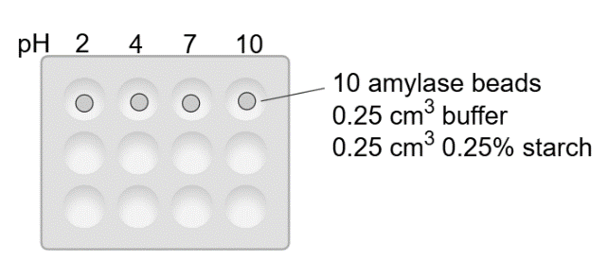
- Add 0.25 cm³ buffer. Use a different pH buffer for each well of the dimple tile as shown in the diagram.

- Add 0.25 cm³ starch to each well.

- Float the dimple tile in a basin of warm water for 10 minutes.

- Add 1 drop of iodine and record the colour of the solution. Use the RGB detector app to quantify the RGB values of the solution.

Results
pH | Colour of iodine
 | Colour | R(%) | G(%) | B(%)
2
4
7
10

Part 5: Effect of substrate concentration on amylase activity
Materials required (per pair):
40x Amylase immobilised beads | 0.5 cm³ 0.1%, 0.2%, 0.4%, 0.6% starch
forceps | Dimple tile
P1000 pipette + tips | Stop watch
0.005 M iodine | Basin of warm water
RGB detector app for smartphone

Method
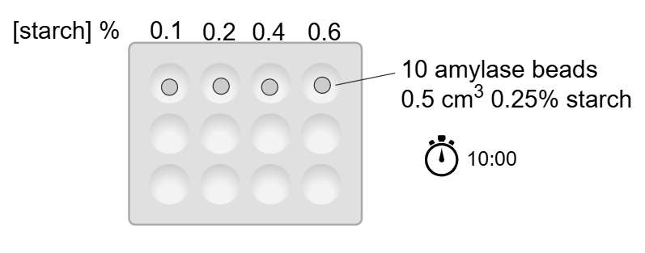
- Transfer 10 amylase beads to separate wells of a dimple tile.

- Add 0.5 cm³ starch of a different concentration to each well.

- Float the dimple tile in a basin of warm water for 10 minutes.

- Add 1 drop of iodine and record the colour of the solution. Use the RGB detector app to quantify the intensity of the R, G and B colours in the solution.

Results
Substrate concentration (%) | Colour of iodine
 | Colour | R(%) | G(%) | B(%)
0.1
0.2
0.4
0.6

