 | Biology Residential Course  Part 1: 6th – 8th October 2011 | 
PREPARATION OF AN ALGAL TUBE

Background  We have published a method for producing a ‘Cabomba tower’ (see Cabomba Tricolour, SSERC Bulletin, 235, 2-4) in which a single strand of Cabomba, in a solution of hydrogencarbonate indicator, is illuminated with different light intensities of light.  In the figure shown here, the upper portion of the tower received 0%, the middle portion 50% and the bottom portion 100% of the incident light.  Thus photosynthesis and respiration can be seen to be taking place in a single plant. | 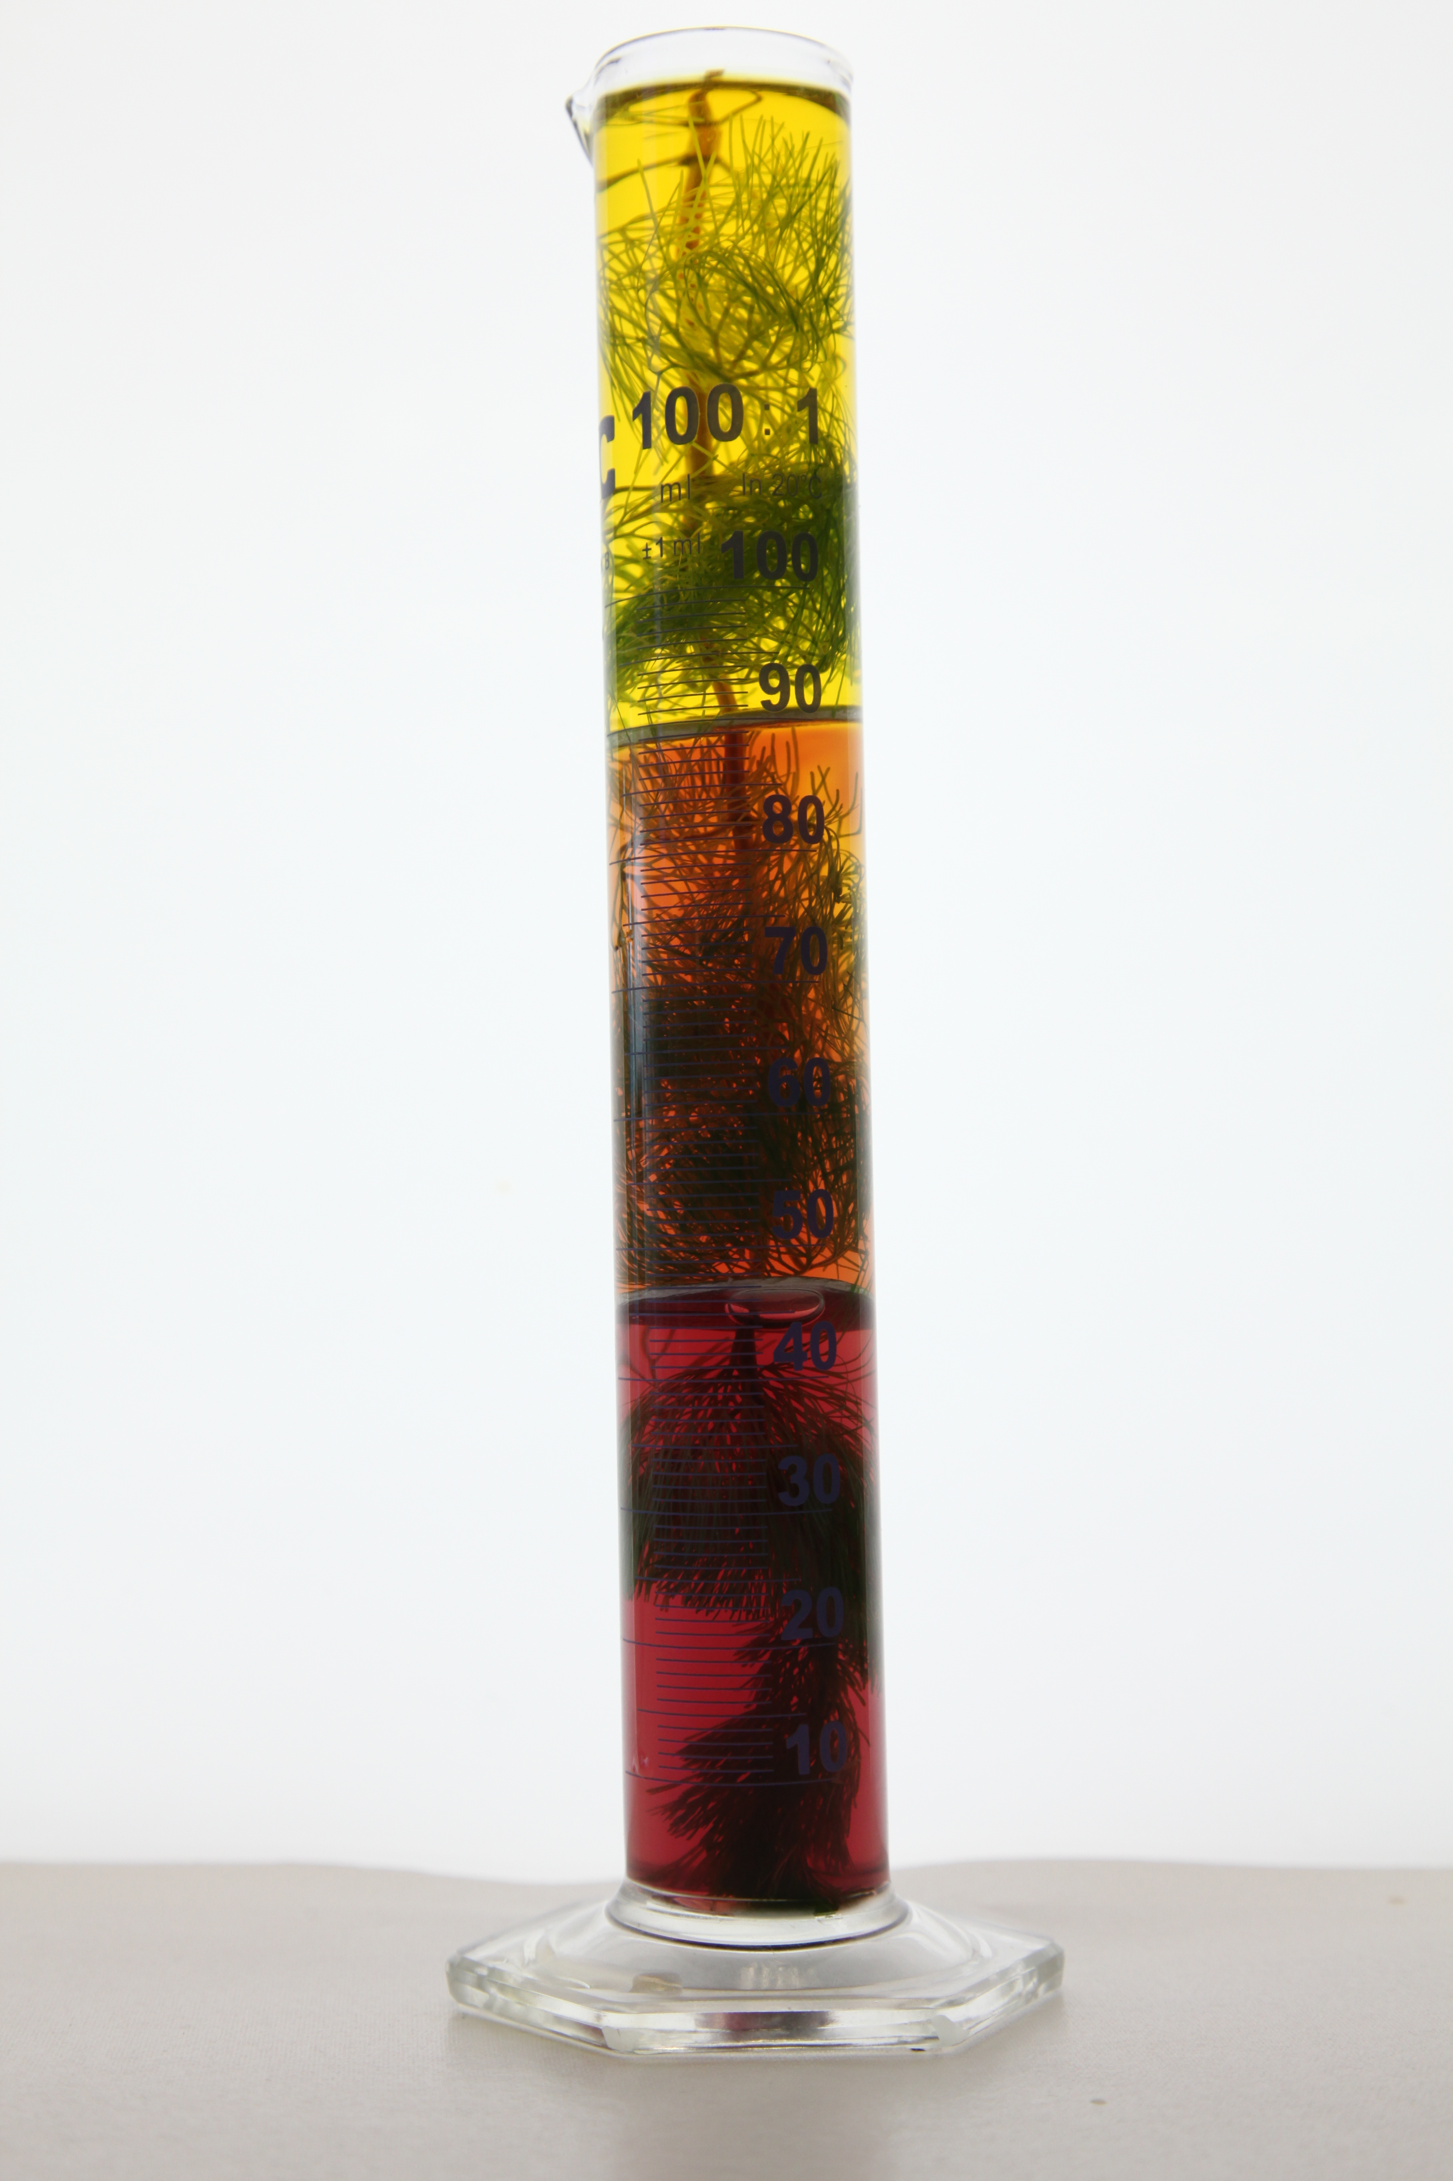

The activity in this part of the session involves the construction of a tube of Scenedesmus quadricauda. Once prepared, the tube will be placed under a light bank and illuminated.

In pairs, you are provided with:

- 50 cm³ of hydrogencarbonate indicator (pH approximately 7.8)
- 5 cm³ of a concentrated solution of the alga Scenedesmus quadrica
- 50 cm length of glass tubing and stoppers
- black card
- a choice of coloured filters
- access to a light source (light bank)
- stirring rod
- 100 cm³ beaker
- scissors and sticky tape

Procedure

- Cut a piece of black card to a length of approximately 1/3 of the length of the glass tube and make a cylinder which will fit around the tube - not too tight because later on you will need to remove the cylinder without disturbing the contents of the tube.
- Repeat step 1 with a piece of coloured filter.
- Firmly stopper one end of the glass tube.
- Pour the algae solution into the beaker and add sufficient hydrogencarbonate indicator solution to give a final volume of about 50 cm³.
- Stir the mixture and add to the glass tube as quickly as possible (try not to let the algae settle). Top up the tube with indicator. Add the second stopper!
- Place cylinders at either end of the tube leaving the middle third without a cylinder.
- Give the tube a thorough mix to ensure the algal suspension is uniformly distributed.
- Place the tube under the light bank.

