Factors that affect fermentation (dough rising)
Aim: To investigate the effect of type of sugar on fermentation in yeast.

Brief background:
Yeast ferment sugar to produce carbon dioxide and ethanol, releasing energy. The production of carbon dioxide is useful in bread making, as it causes the dough to rise. The rate of fermentation can be measured indirectly by measuring the change in dough height over time. In this low-cost practical, learners can work in groups of four to investigate the volume of carbon dioxide produced during fermentation.

Materials (per group of 4):
4x XS Ziploc bag | 320 cm³ warm water
4x ¼ cup measure | 4x 1 tsp measuring spoon
4x 100 cm³ measuring cylinder | 4x 0.5 tsp measuring spoon
2x rulers | 2 tsp x Baker’s yeast
400 g self-raising flour | 1x tsp of sugar (choice of: glucose, sucrose, lactose, starch)
Gratnell tray | Spoon or spatula
Blue roll

Method:
In your groups, each person should be responsible for one dough. In your groups of 4, decide which sugar each person will investigate.

- To a Ziploc bag, add:
  - 1 teaspoon sugar (choose from glucose, sucrose, lactose, starch)
  - 0.5 teaspoon yeast
  - 80 cm³ warm water

- Seal the bag and gently agitate to incorporate the yeast and sugar into the water. Leave for 5 minutes.

- Add 3x ¼ cup measures of self-raising flour to the bag. Remove excess air and seal the bag. Avoid getting any dough mixture in the bag seal.
- Gently shake (and later knead) the bag to incorporate the flour into the suspension. At times, you might need to release some gas from the bag – do this carefully because the dough can get into the bag seal and this should be avoided. The spoon can be used if you need to remove some dough from the seal.

- Open the bag slightly to remove excess air. Re-seal and flatten out the bag contents.

- Place a ruler against a flat, vertical surface. Butt the bag containing the dough against the ruler. Place the second ruler on top of the bag, aligned with the first ruler (as shown in the diagram below). Record the height of the dough.
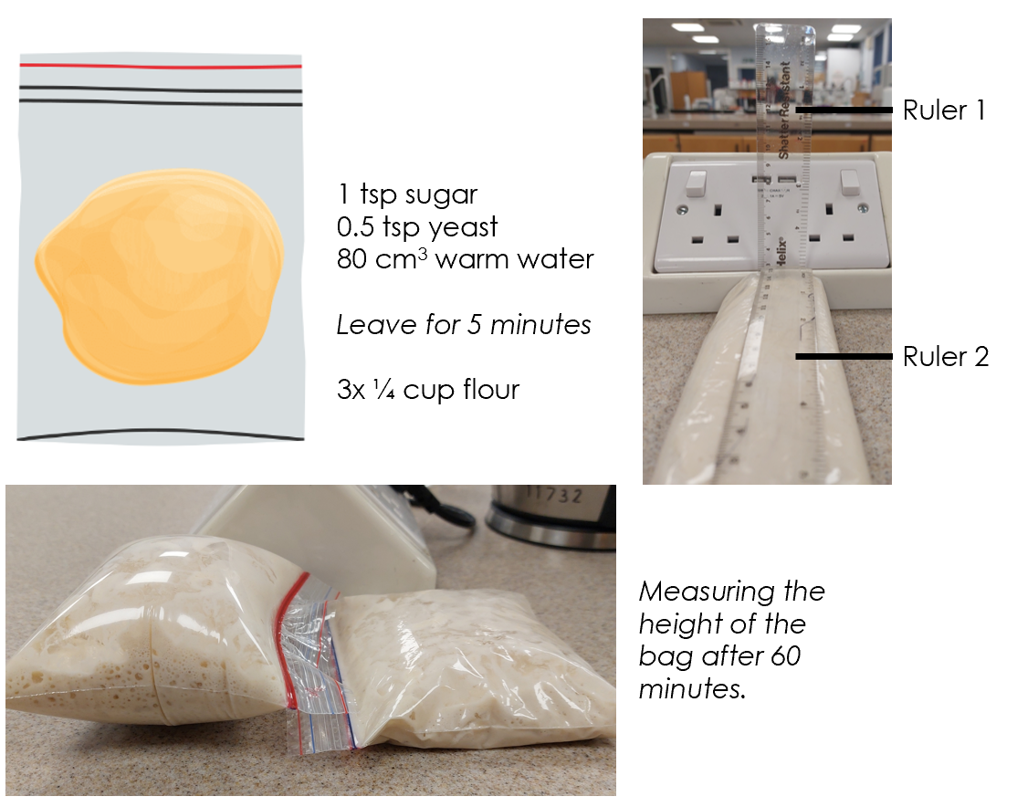
- Place all dough bags in a Gratnell tray and leave at room temperature for 60 minutes. Record the height of the dough using the 2 ruler method. The bag of dough can be disposed of in the domestic waste.

Results
Type of sugar | Height of dough at start (mm) | Height of dough after 60 min (mm) | Change in dough height (mm/hr)
Glucose
Sucrose
Lactose
Starch

For an assignment, learners can work in groups of 4, with each learner responsible for the repeats of each “type of sugar” (for example). Various independent variables are available for this investigation. Examples include:
Flour type | Mass of yeast | Type of sugar | Mass of sugar | Temperature | incubation time
Strong white bread flour | 0 tsp yeast | Sucrose | 0 tsp sugar | 4 °C | 30 min
Wholemeal bread flour | 0.25 tsp yeast | Glucose | 0.5 tsp sugar | 20 °C | 60 min
Plain flour | 0.5 tsp yeast | Lactose | 1 tsp sugar | 40 °C | 90 min
Self-raising flour | 1 tsp yeast | Starch | 1.5 tsp sugar | 60 °C | 120 min

The incubation time can be adjusted to fit into a period. Our recommendation would be to leave for a minimum of 30 minutes.

